**SAP BW/BO Exercise**

**HANA Calculation View Data Modeling**

**Note: You must use the following conventions to name objects/systems created in this exercise.**

**Replace S with the semester**

**A for Fall**

**B for Spring**

**C for Summer**

**Replace XX with the two-character year (ex. 20 for 2020)**

**Replace YYY with your Student ID (ex. 147 if you were issued ID GBI_147)**

**Please use the screenshots ONLY as a reference. The instructions have to be followed AS-IS.**

**Objective**

In the previous exercise we created sales cube view. In this exercise we will be creating another cube view for the planned data and combining these two cube views in a calculation view.

**1.) Create the database table**

We will create a table which is similar to the **sales_yyy** table created in the first data modelling exercise but which has data forecasted for the years 2021 to 2026.

**Remark:** You create all database tables in the database schema GBI_YYY where YYY defines the student number provided.

* 1. ) Login to SAP HANA SPS12

<http://db1.hana2.ucc.uwm.edu:8002>

Login with your UserId and password. The below given screen will appear:

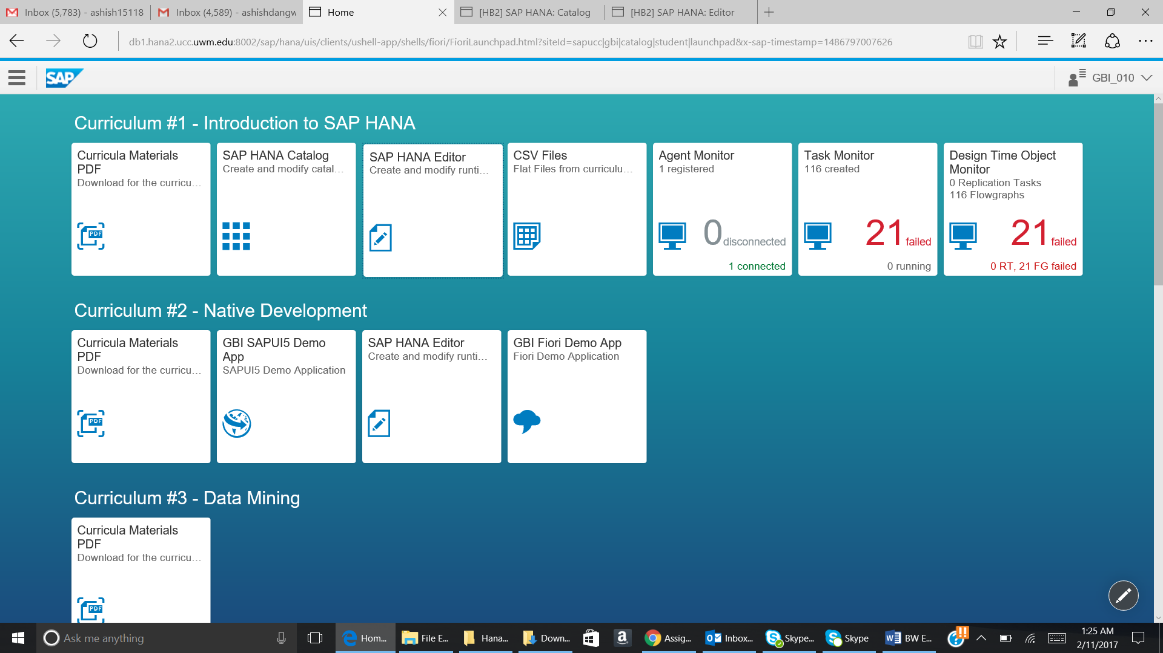

Now open the SAP HANA Editor.

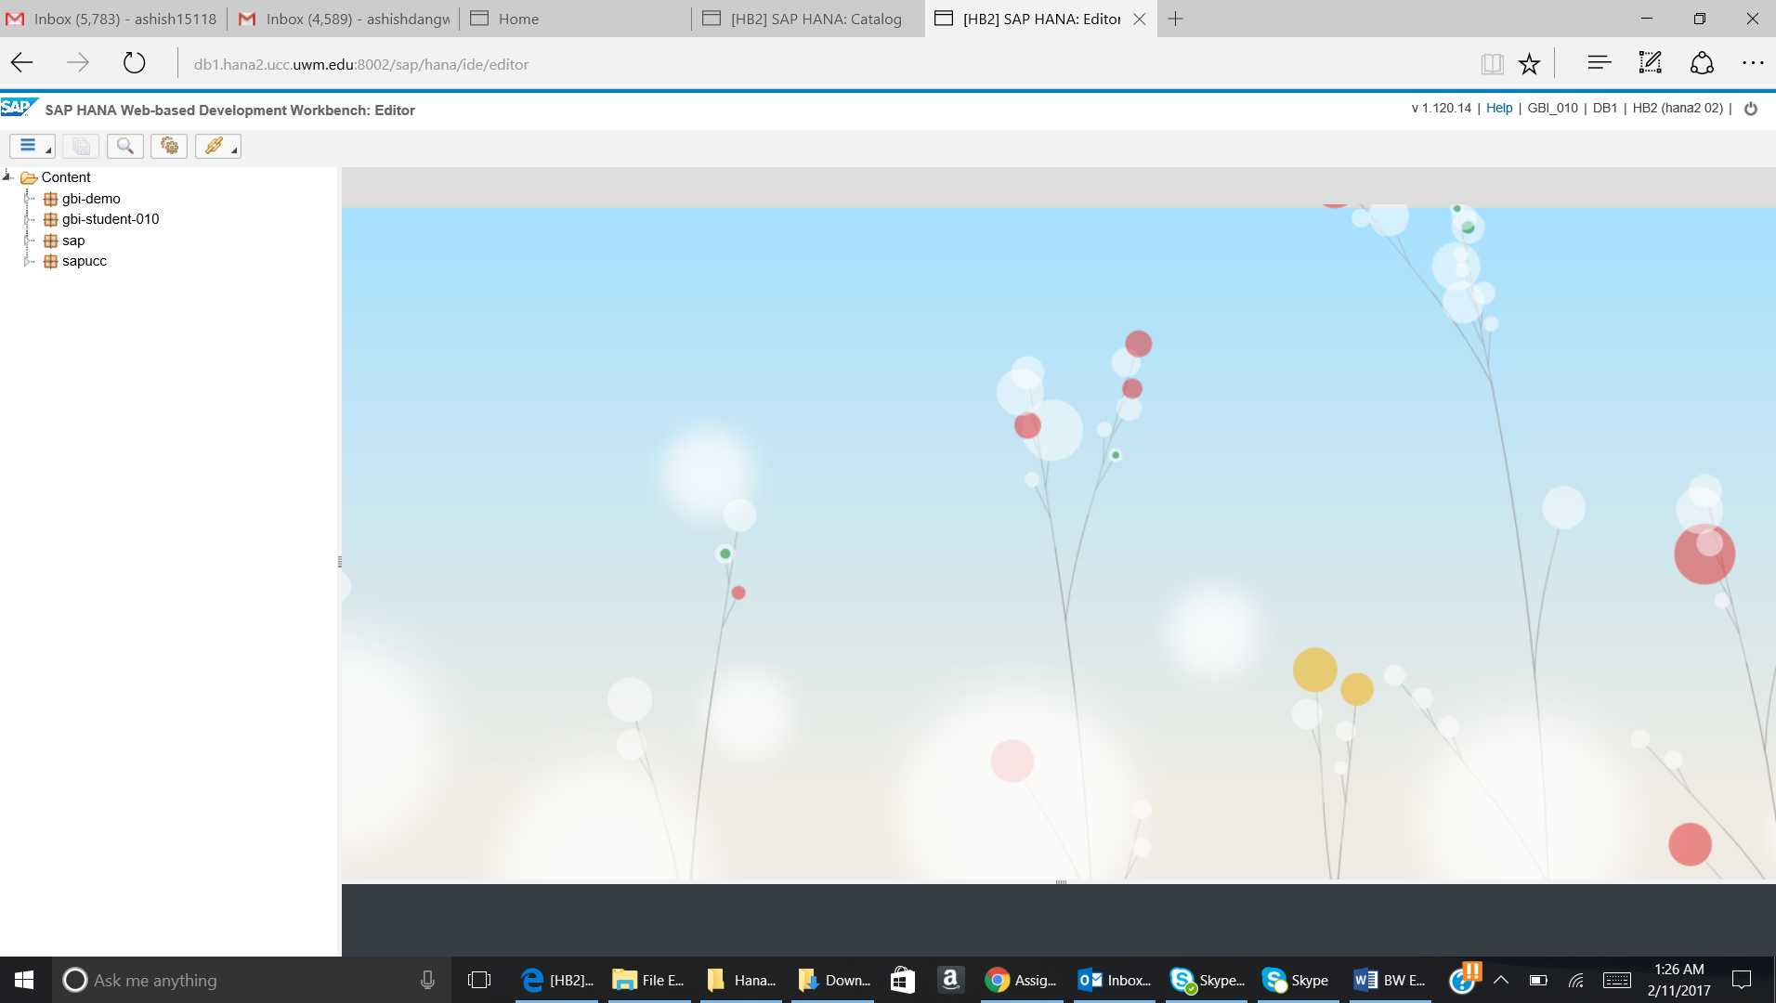

* 1. ) Now create the SALES_PLAN_YYY table as per the below given details:

**Table name:** SALESS_PLAN_YYY

**Table type:** Column Store

Add following columns to the table:

|  |  |  |  |
| --- | --- | --- | --- |
| Name | Key | Data type | Length (Dim) |
| ORDER_ID | X | VARCHAR | 10 |
| ORDER_DATE |  | DATE |  |
| ORDER_PRIORITY |  | VARCHAR | 15 |
| ORDER_QUANTITY_PLAN |  | INTEGER |  |
| SHIP_MODE |  | VARCHAR | 30 |
| SHIPPING_COST |  | DECIMAL | 17,2 |
| PRODUCT_ID |  | VARCHAR | 18 |
| CUSTOMER_ID |  | VARCHAR | 20 |

Please follow the below given step:

Go to:

Editor perspective -> Content -> gbi-student-yyy -> Right click -> New -> File

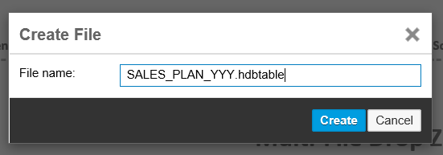

Click on Create.

Write the below given script in the editor:

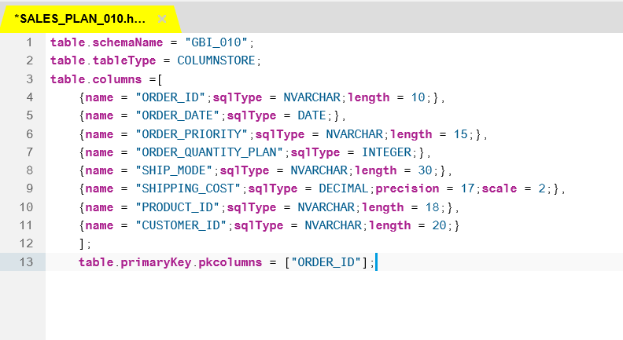

Click on Save. The below given message will come.

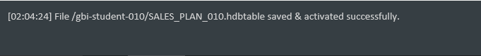

Paste the screenshot of success message:

* 1. Now go to the Catalog. Click on SAP HANA Catalog.

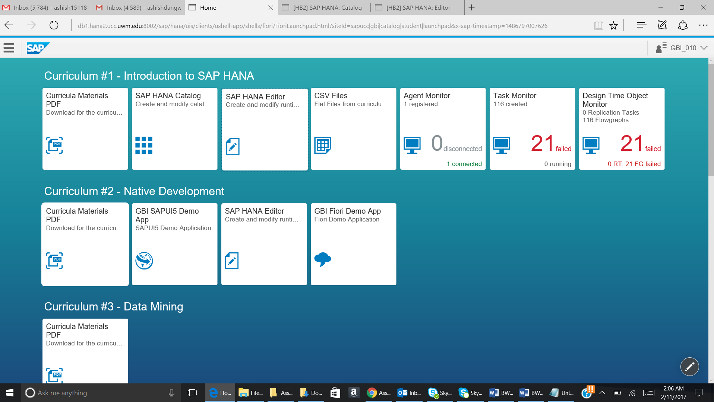

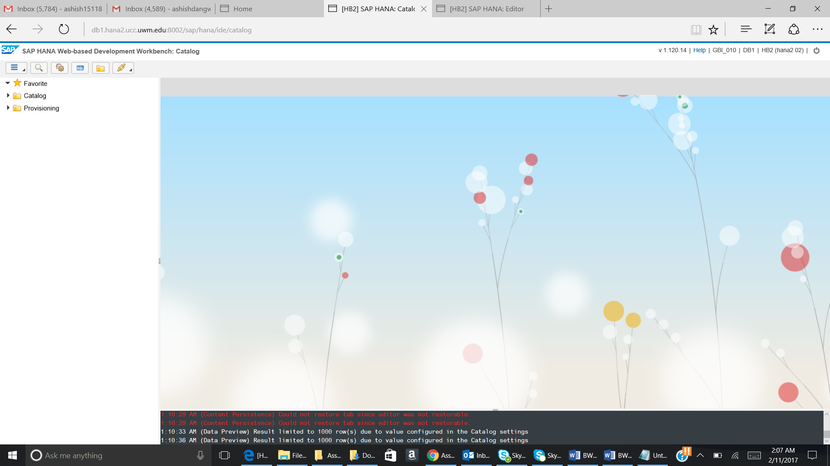

Go to Catalog -> GBI_YYY -> Tables. The newly created table will be shown as given below:

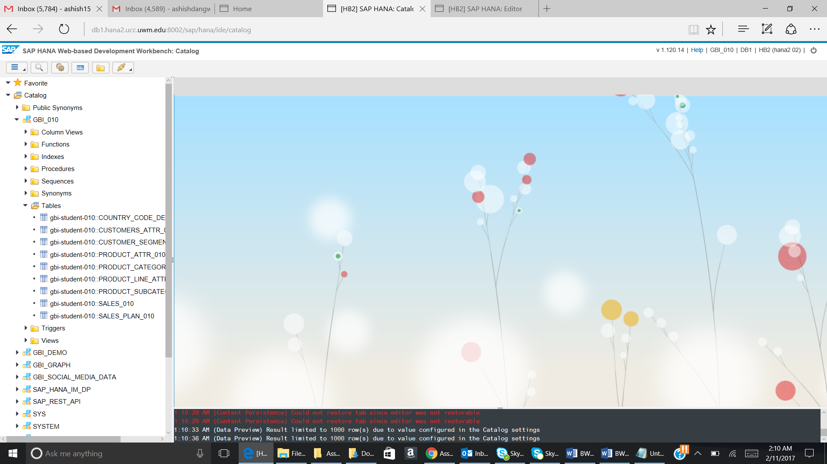

* 1. Now we will do Data Provisioning.

Data Provisioning will be done with the help of SAP HANA Desktop application:

Open SAP HANA SPS12 Desktop application.

Go to Catalog -> GBI_YYY -> Tables.

You will see the below given screenshot:

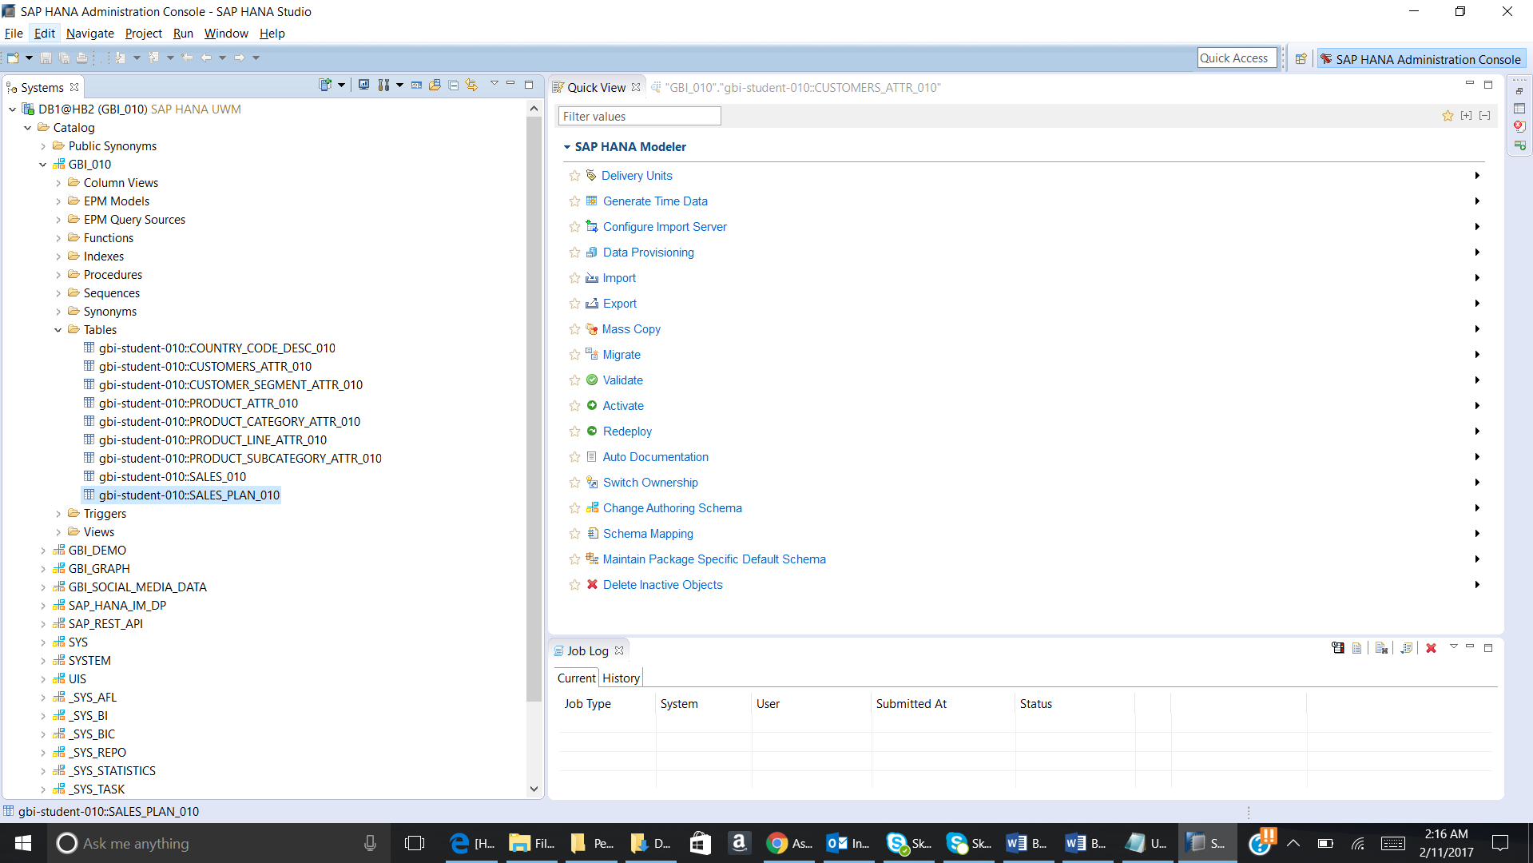

Now go to File and then select Import.

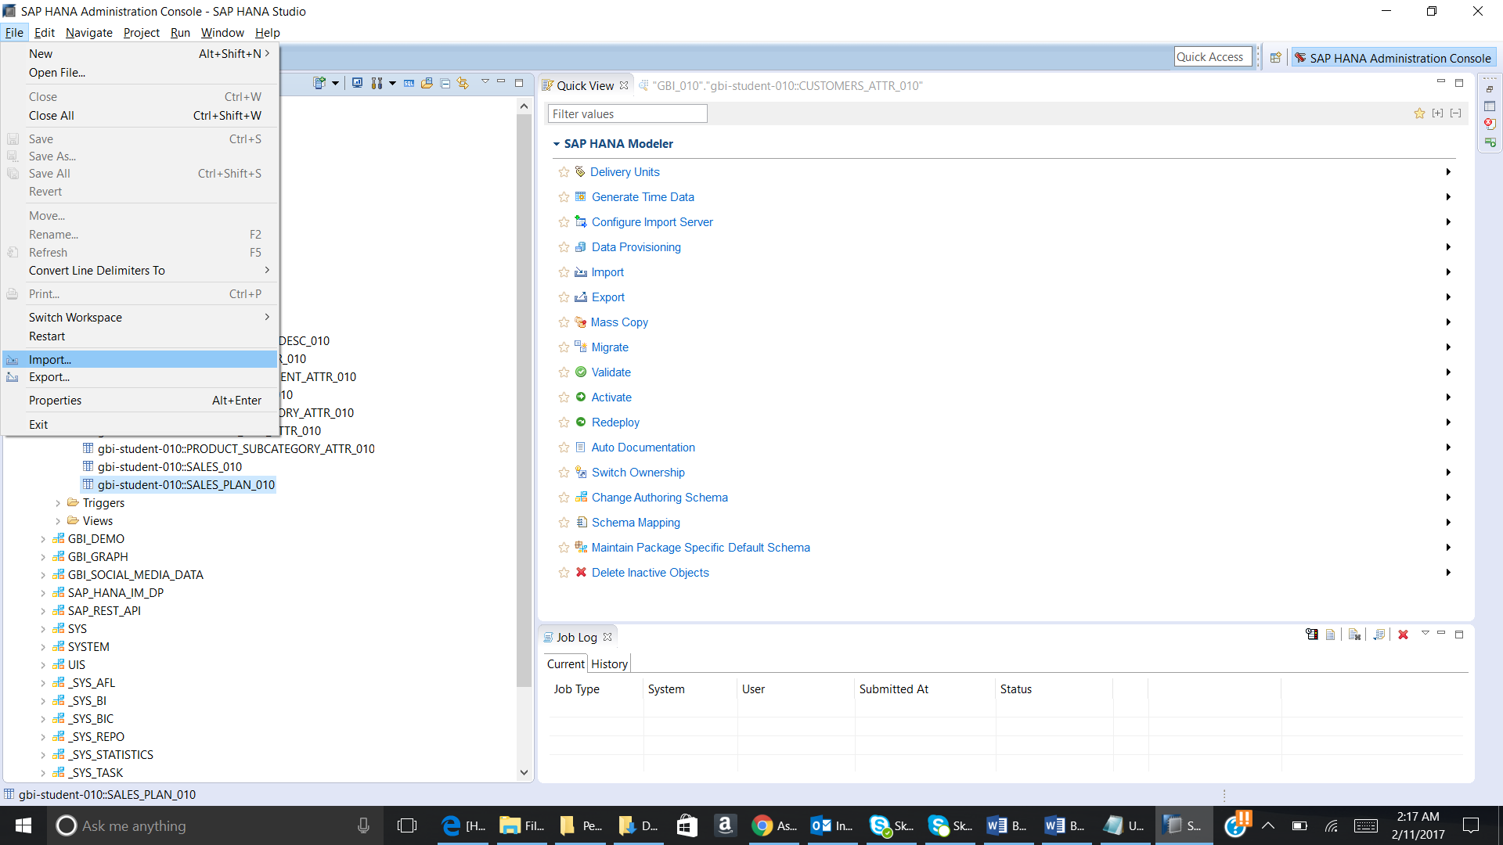

Select Data from Local File:

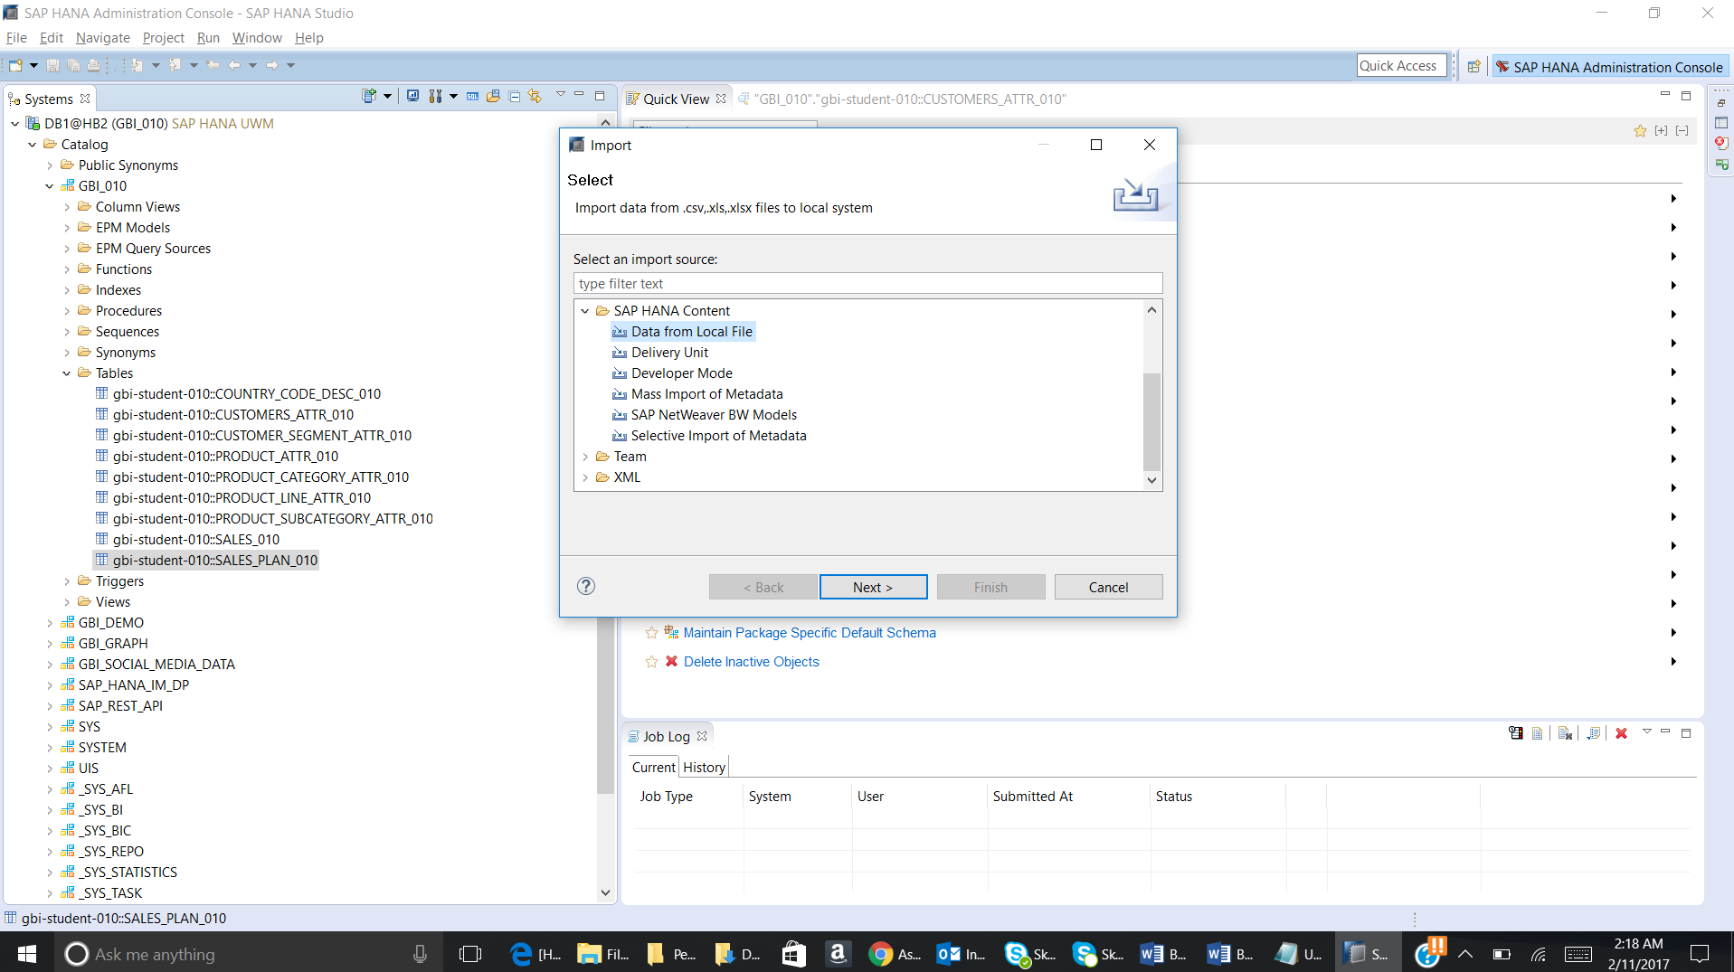

Click on Next

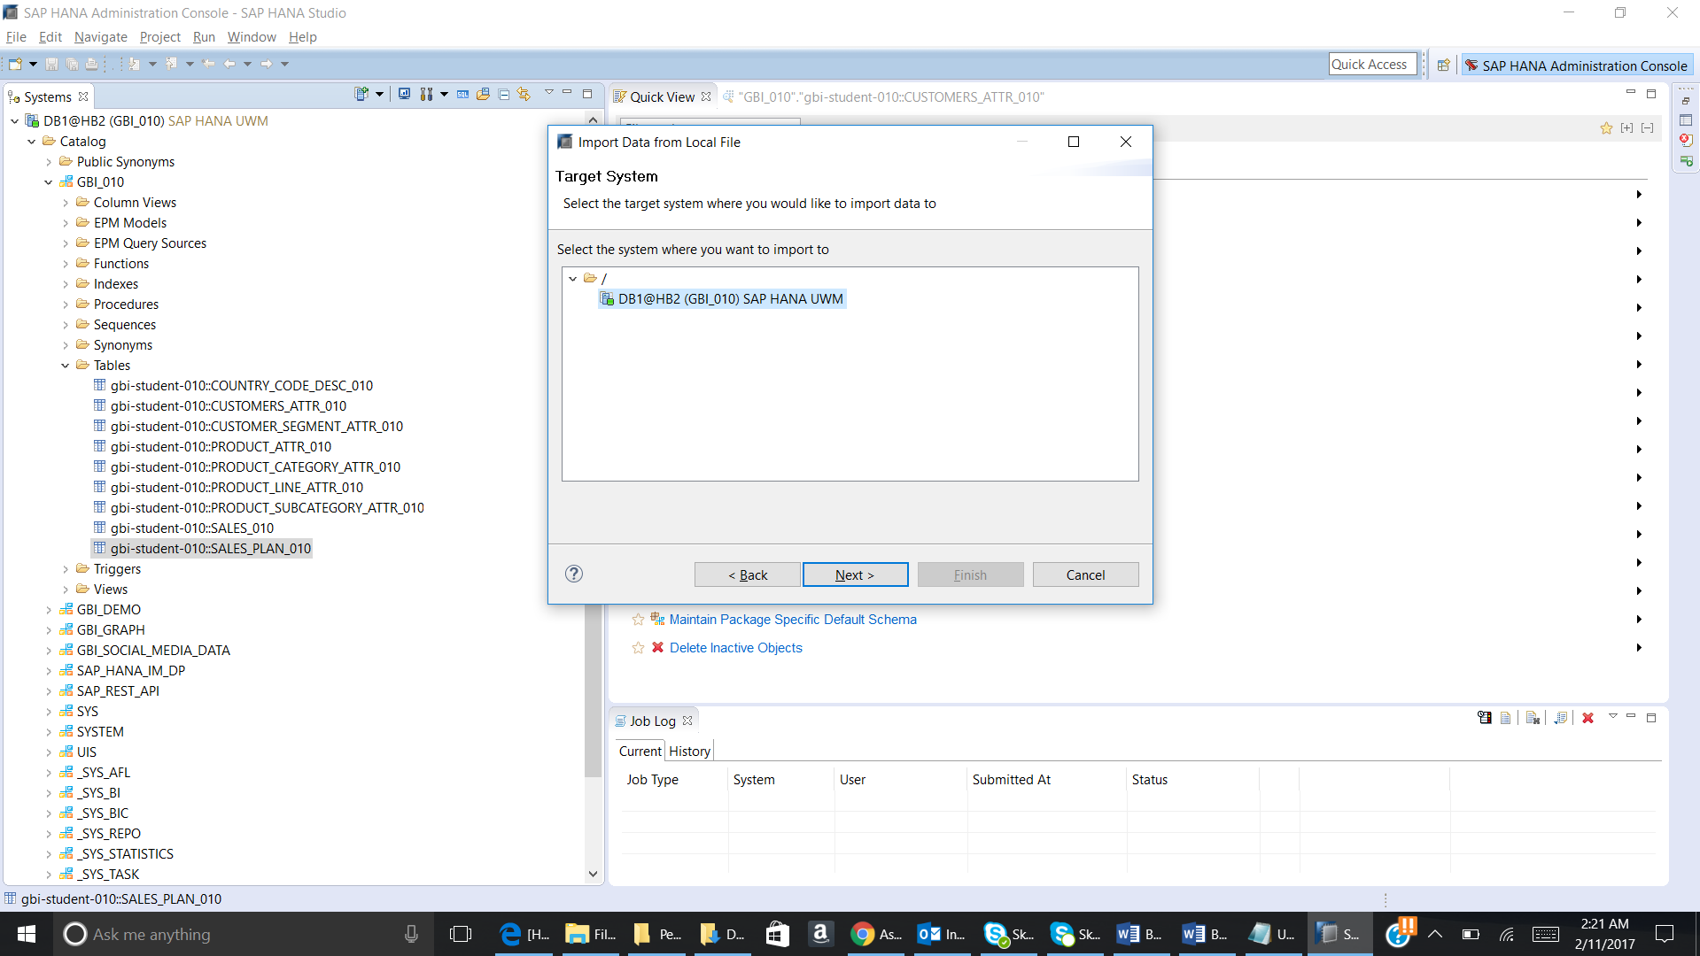

Select the above given system and click on Next.

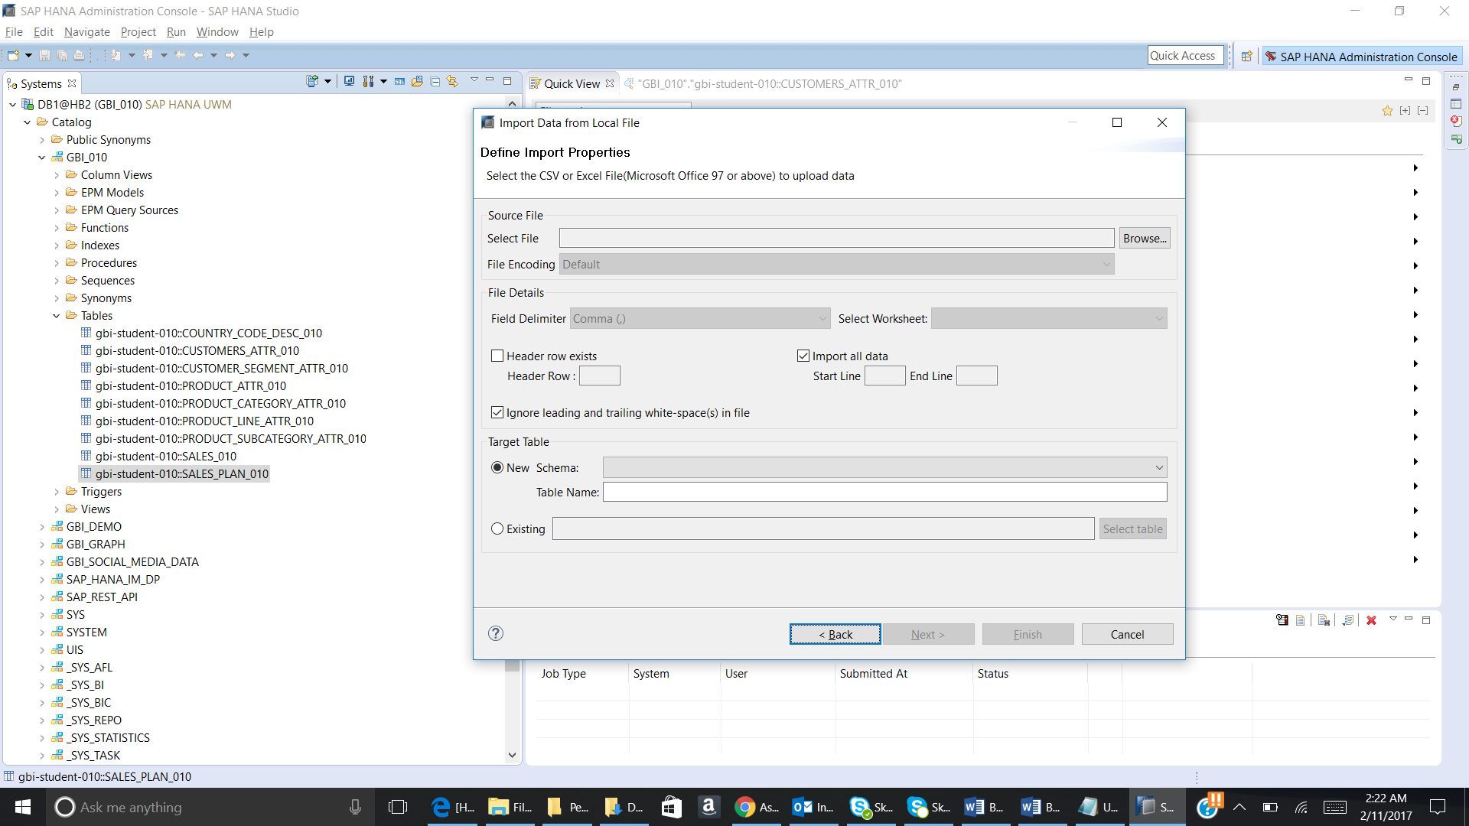

Enter the below given details in the pop up.

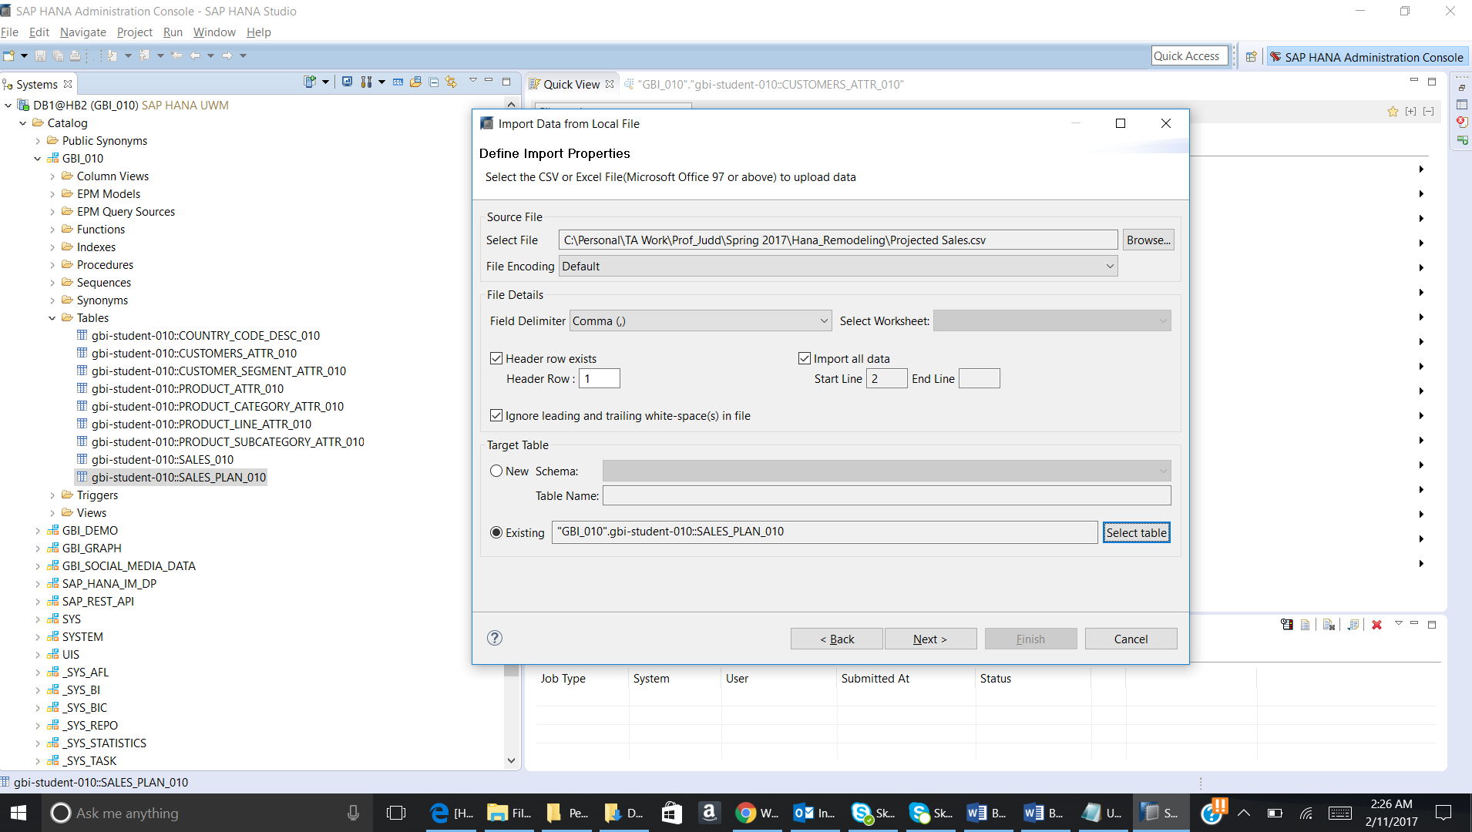

Now click on Next.

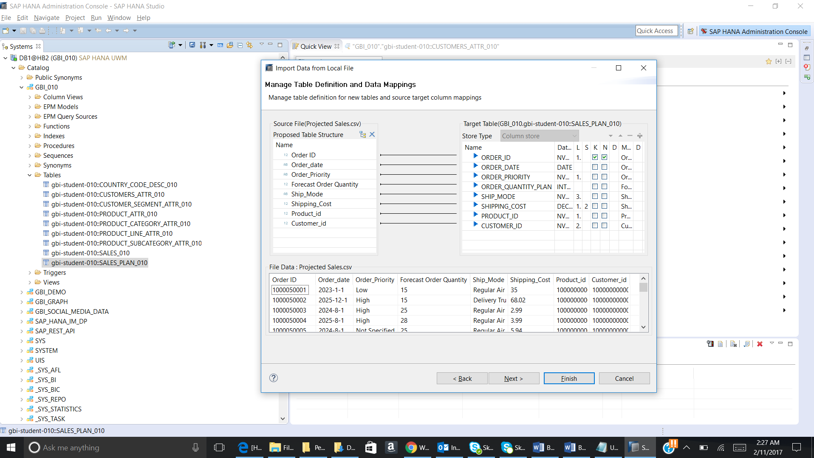

Click on Finish. The below given message will come.

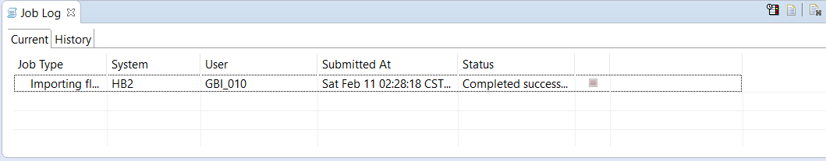

Paste the screenshot of the success message.

Now right click on table and then click Open Data Preview. Paste the screenshot:

**4.) Create an cube view**

Create a new cube view for the planned data in your package

Use following details to create the view:

**View name**: PLAN_AV_**YYY**

**Label**: PLAN_AV_**YYY**

**Tables:** SALES_PLAN_**YYY**

**Views:** CUSTOMER_ATV_**YYY and** PRODUCT_ATV_**YYY**

**Steps**:

* 1. Generating time data: To generate the data from the years 2021 to 2026 we need to do the following steps:

1. Go to Editor page and then click on icon on the top left corner.

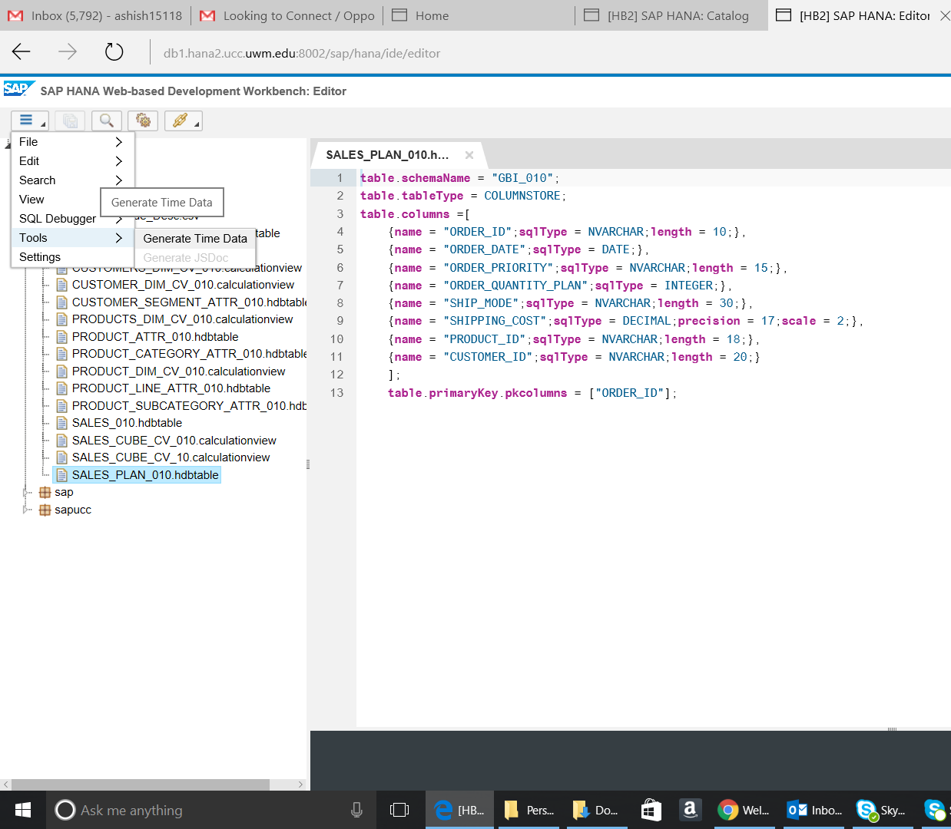

1. Click on generate time data. The below given pop up will come.

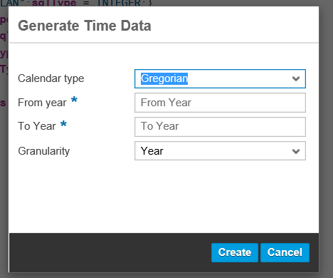

Enter the values as given below:

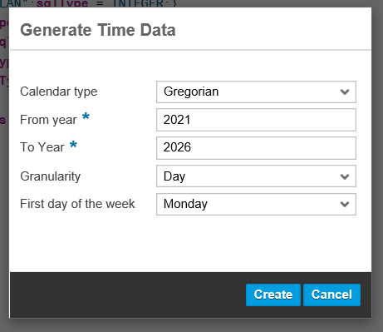

* 1. Right click on gbi-student-yyy. Click on New and then Calculation View. The below given pop up will come:

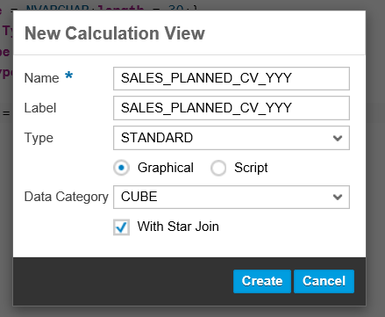

Fill the details as given above and then click on Create.

The below given screen will come:

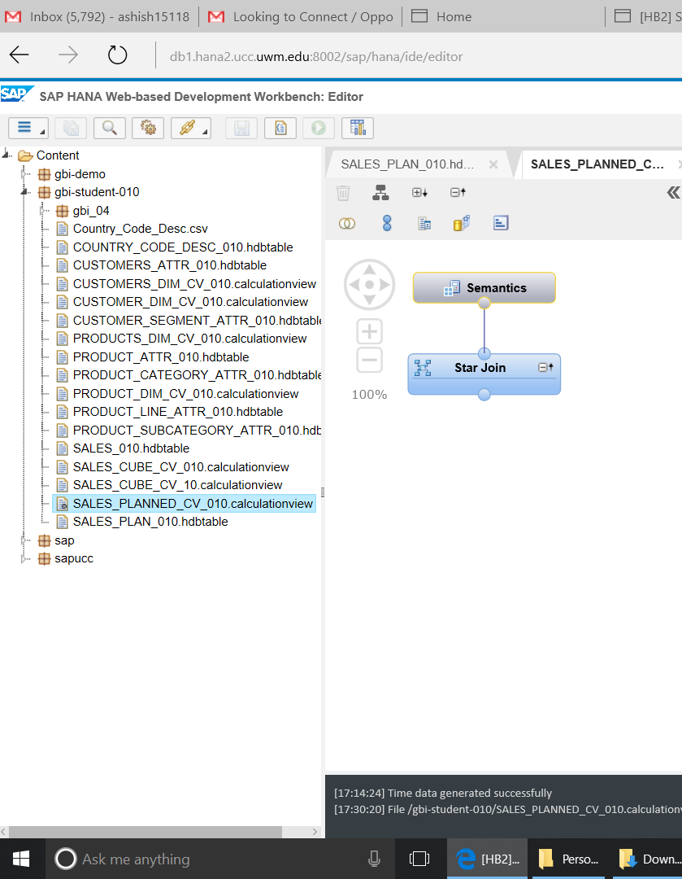

* 1. Drag the Projection on the canvas.

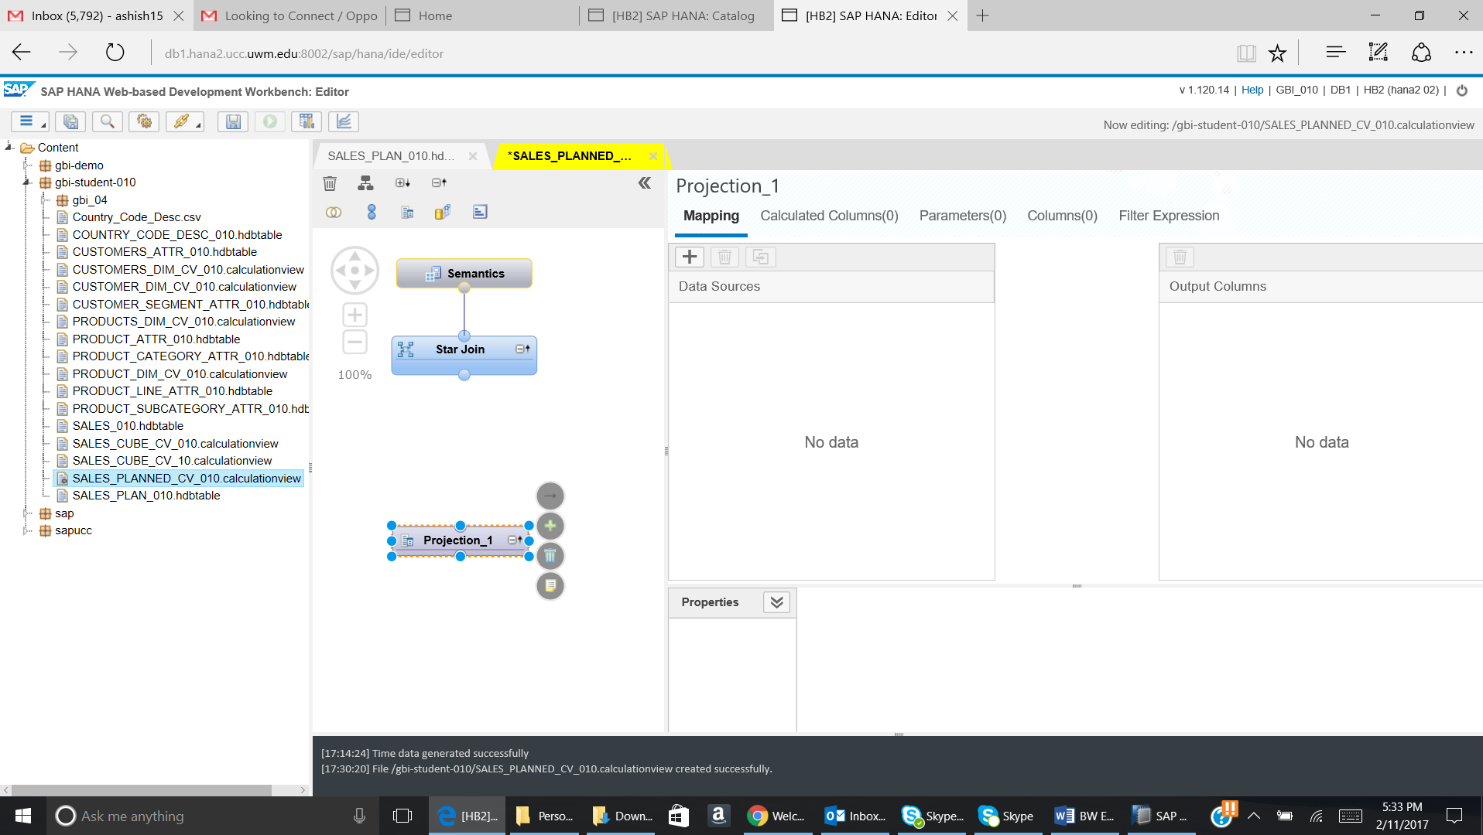

Click on the + sign. The below given pop up will come:

In the pop up search for Sales_Plan_YYY table. Select the table and then click on OK.

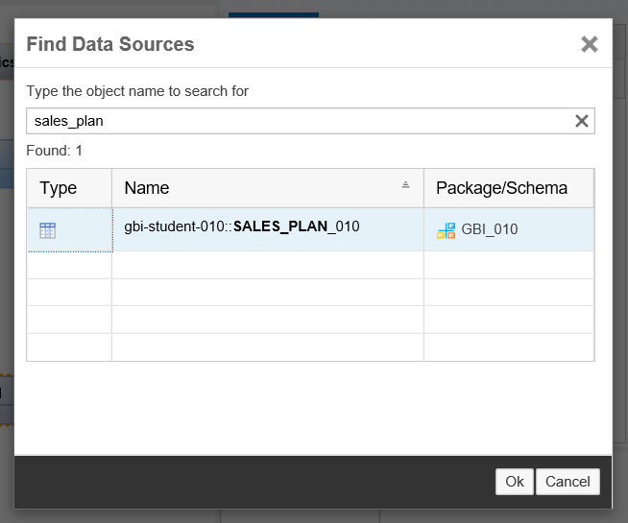

The table will be added into the Projection.

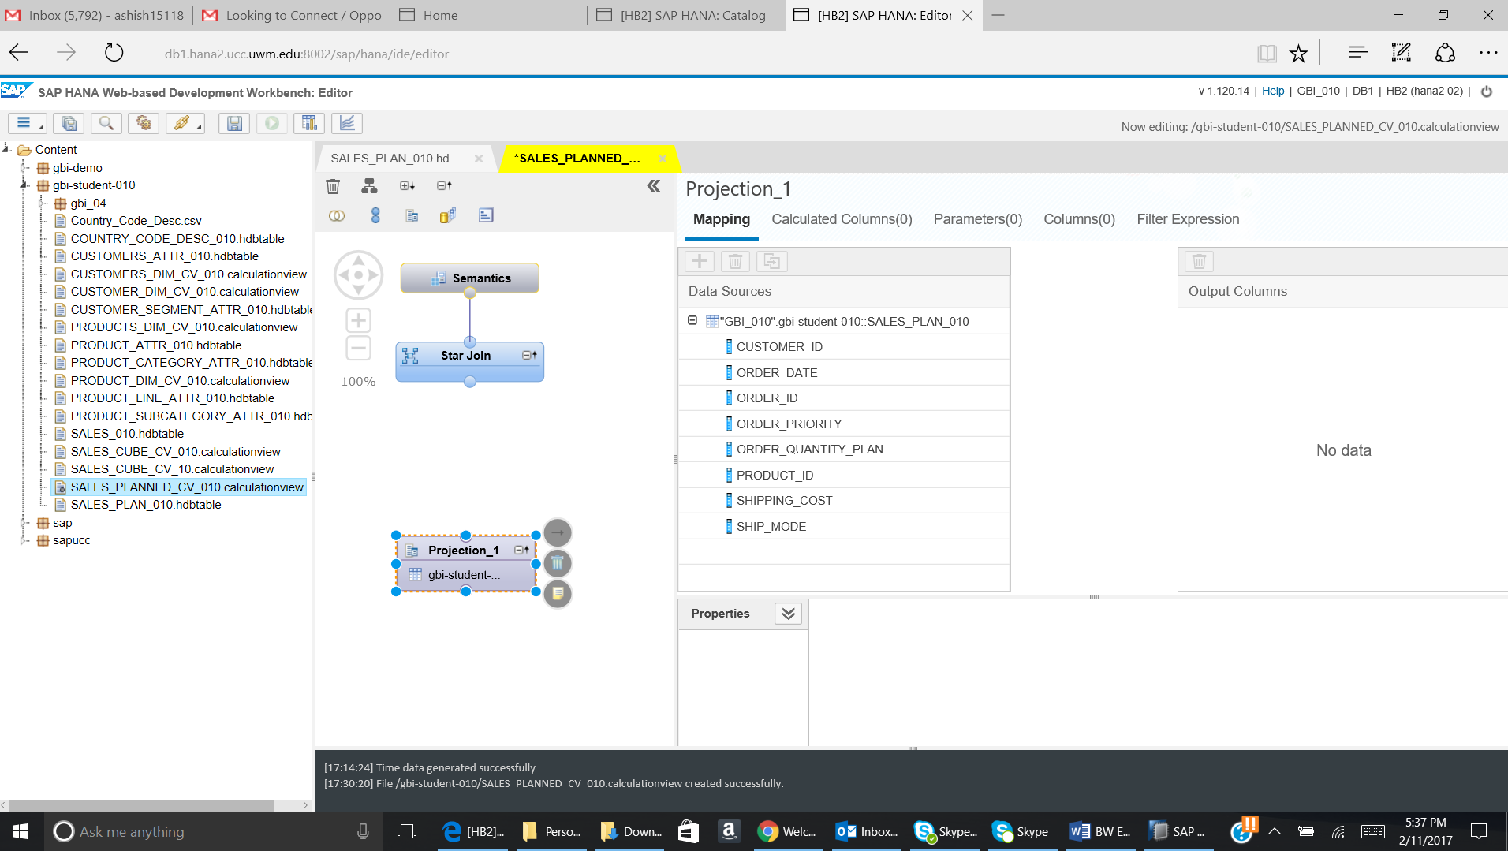

Map all the fields to the output:

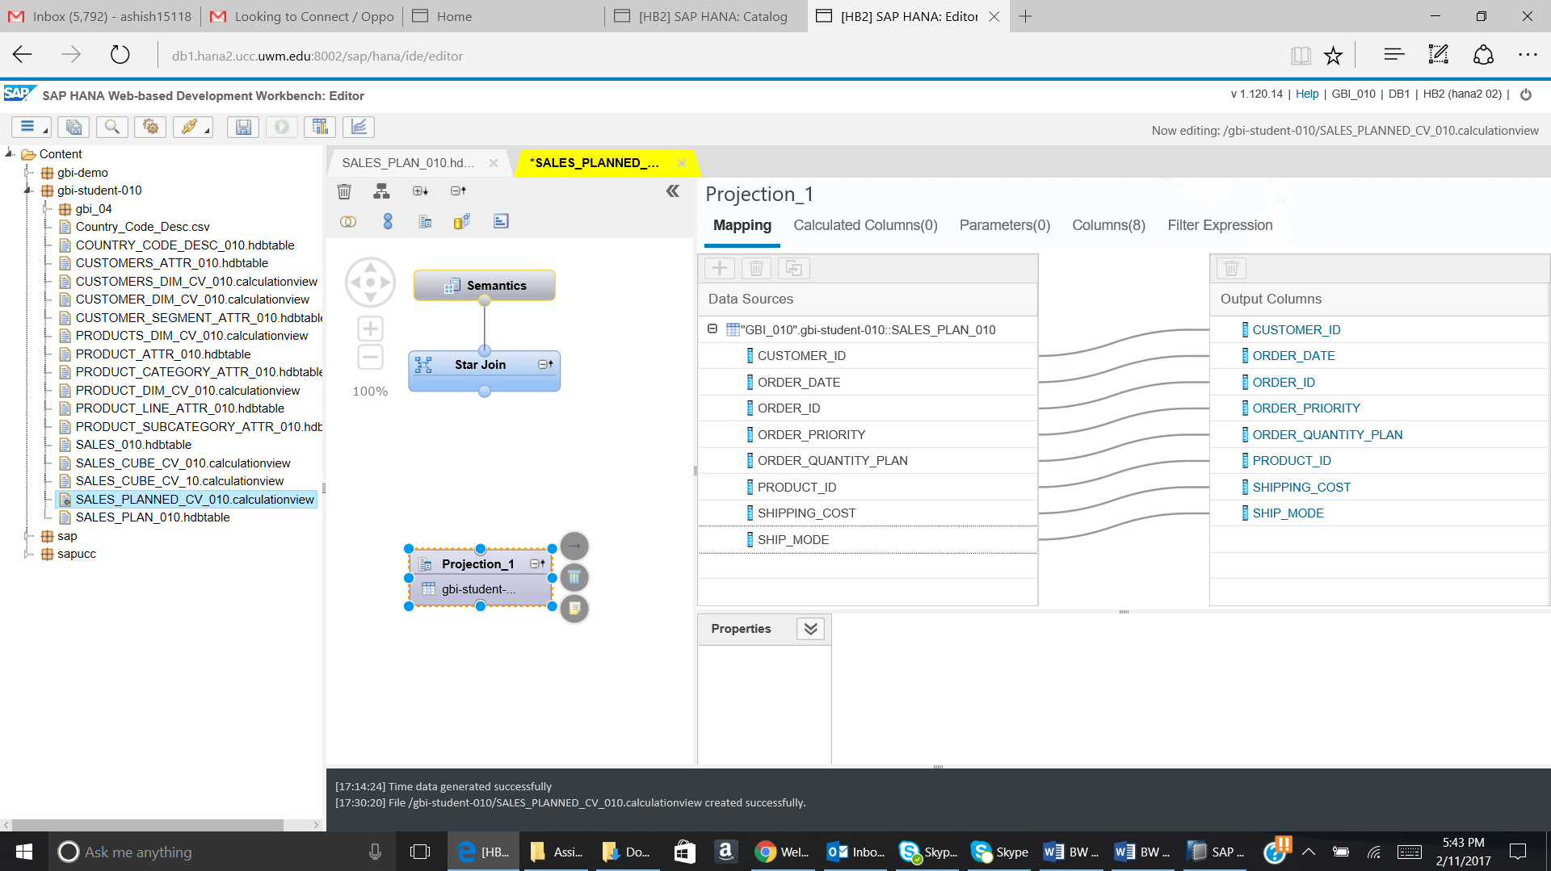

* 1. Now we will drop a join on the canvas:

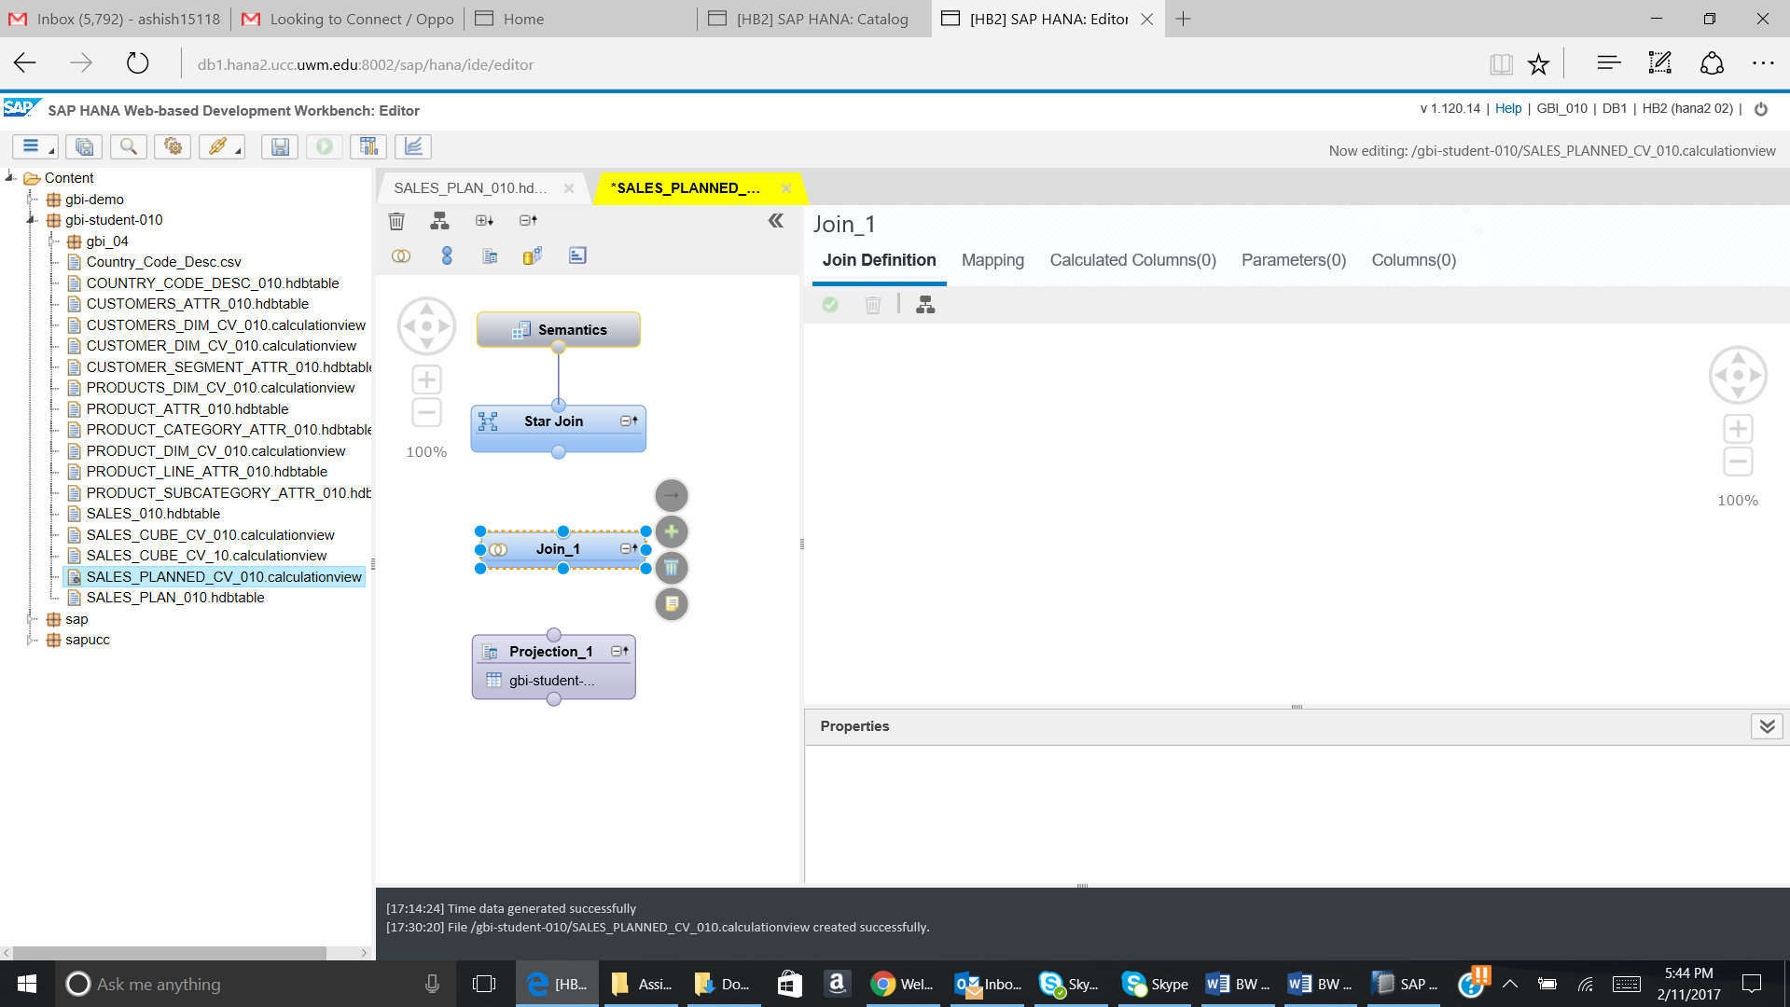

Now join Projection_1 to the Join_1.

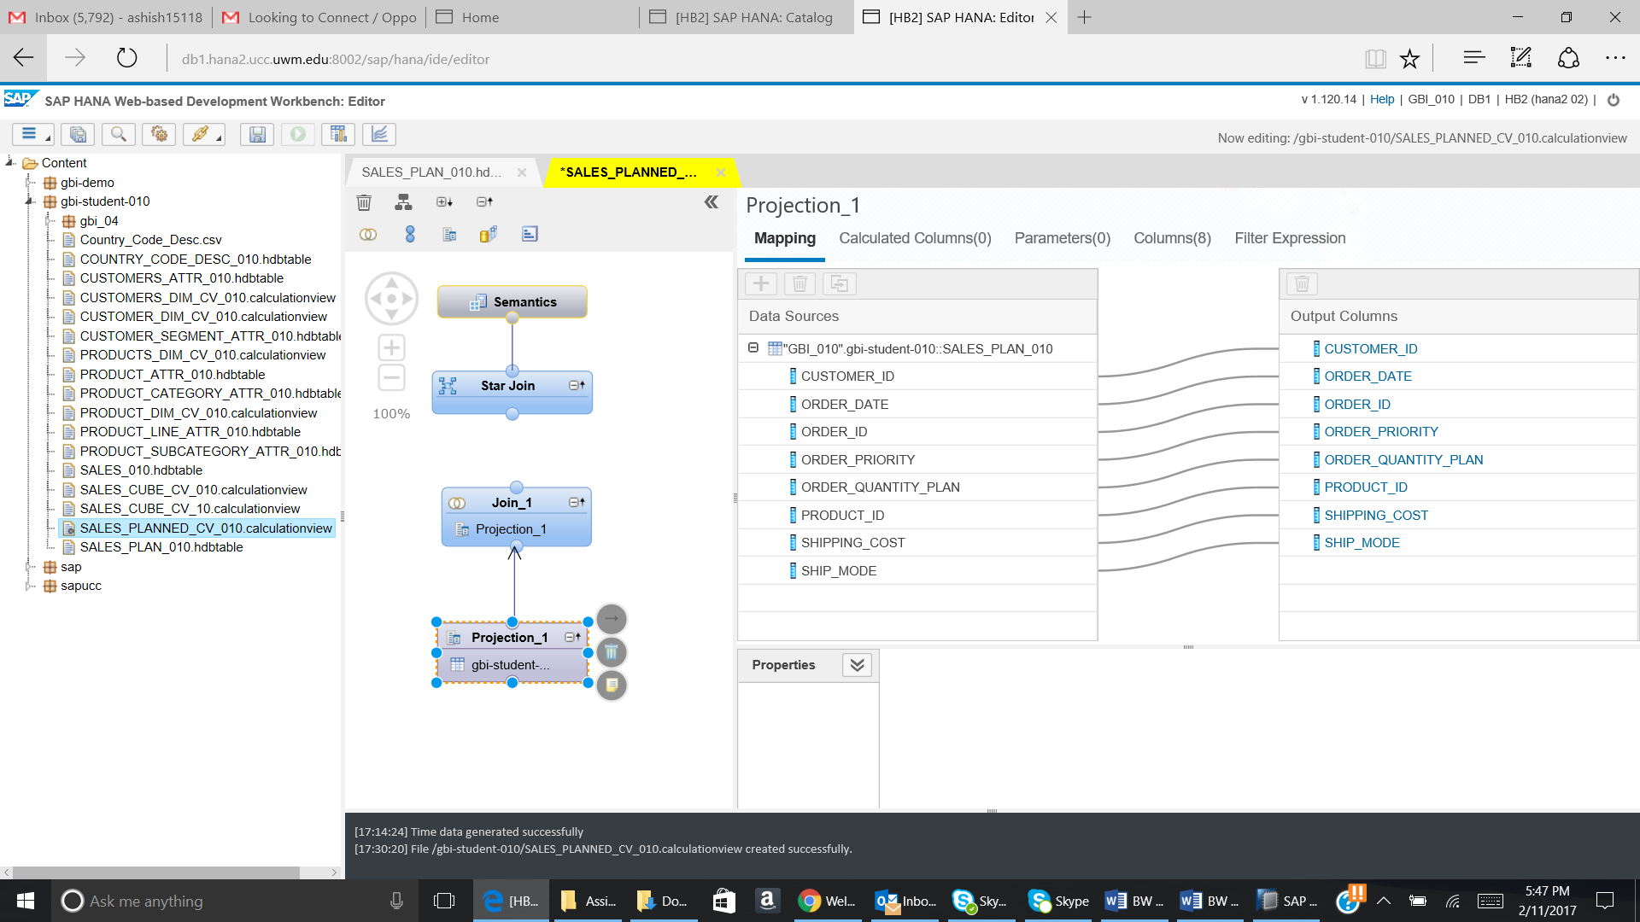

Now click on Join_1 and + sign will appear. Click on + sign and a pop up will come. Search for M_Time_Dimension table.

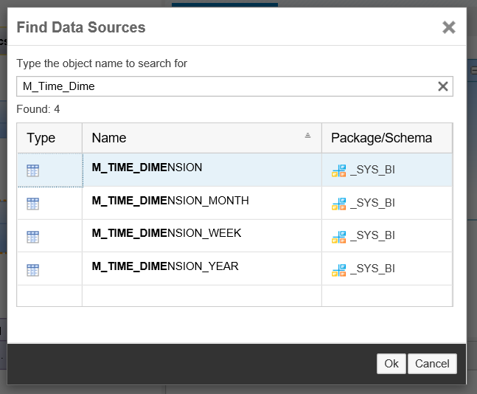

Select the table and then click on OK.

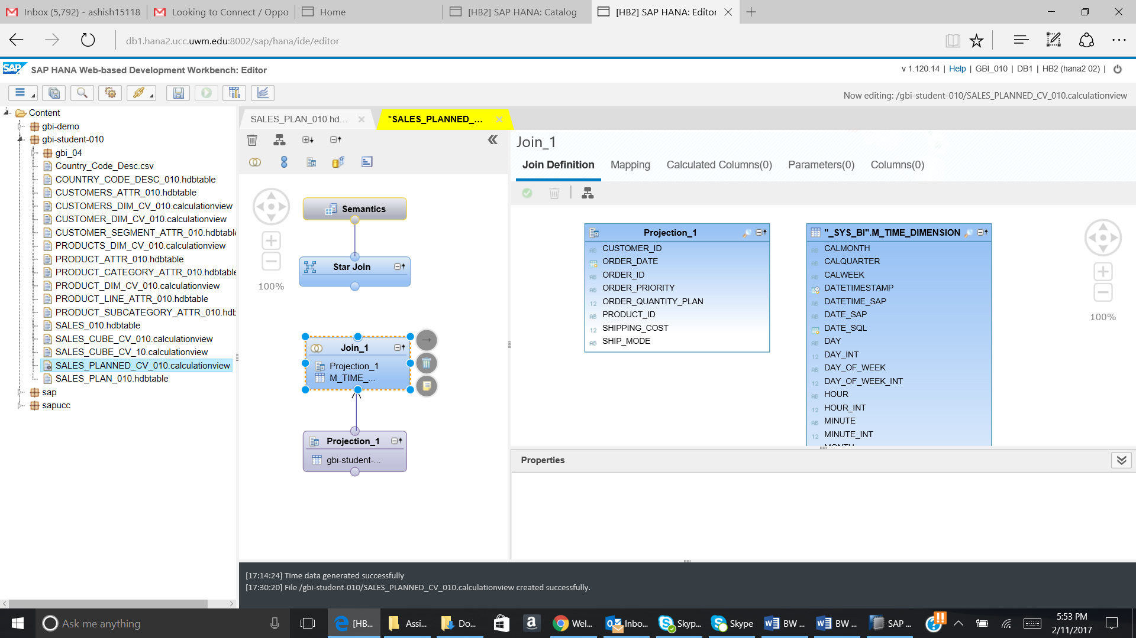

Drag the Order_Date from Projection_1 to Date_Sql of “_Sys_Bi”.M_Time_Dimension.

The tables should look like below:

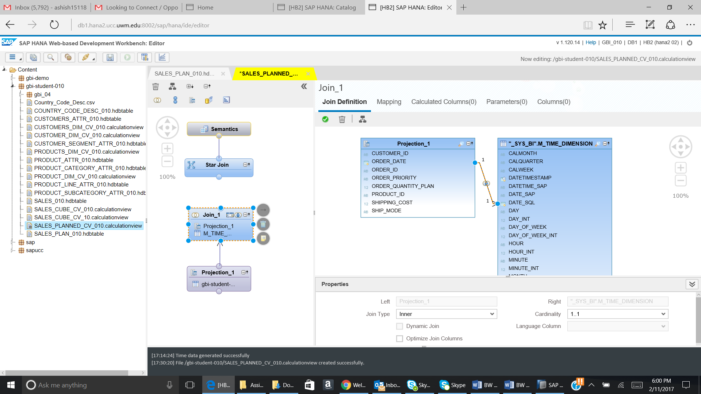

Go to mapping tab. Perform the mapping as given below:

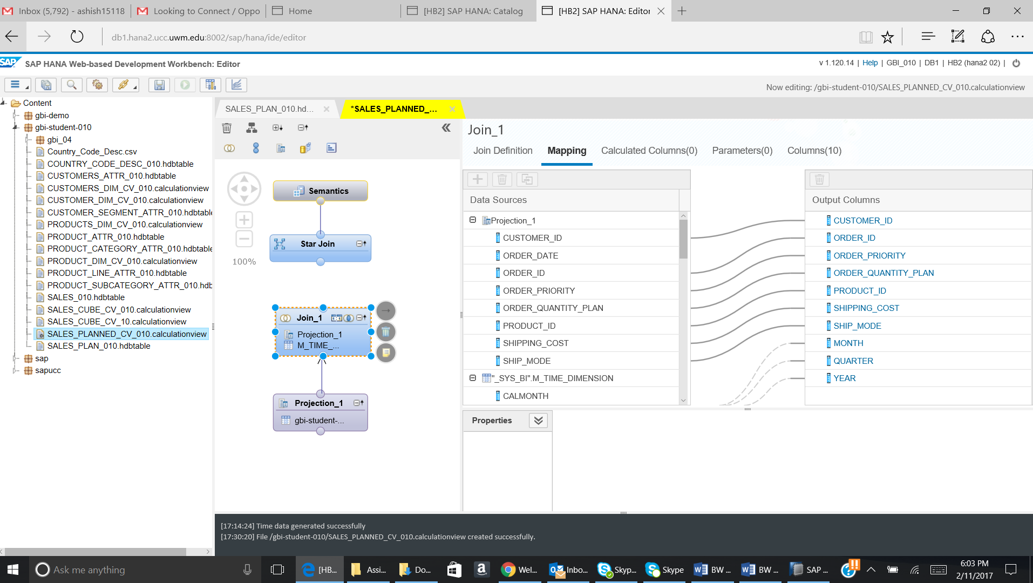

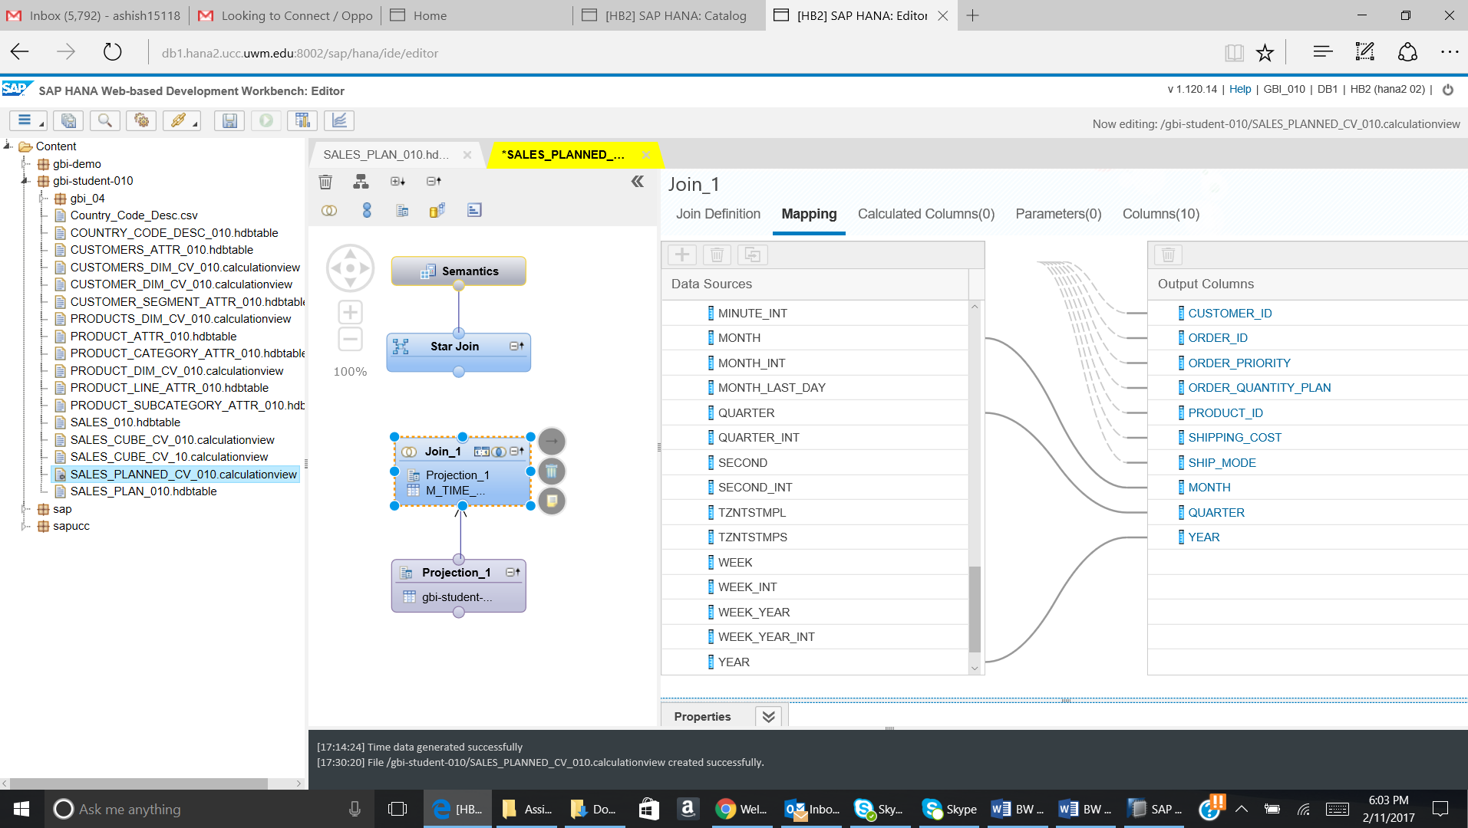

* 1. Now join Join_1 to the star join.

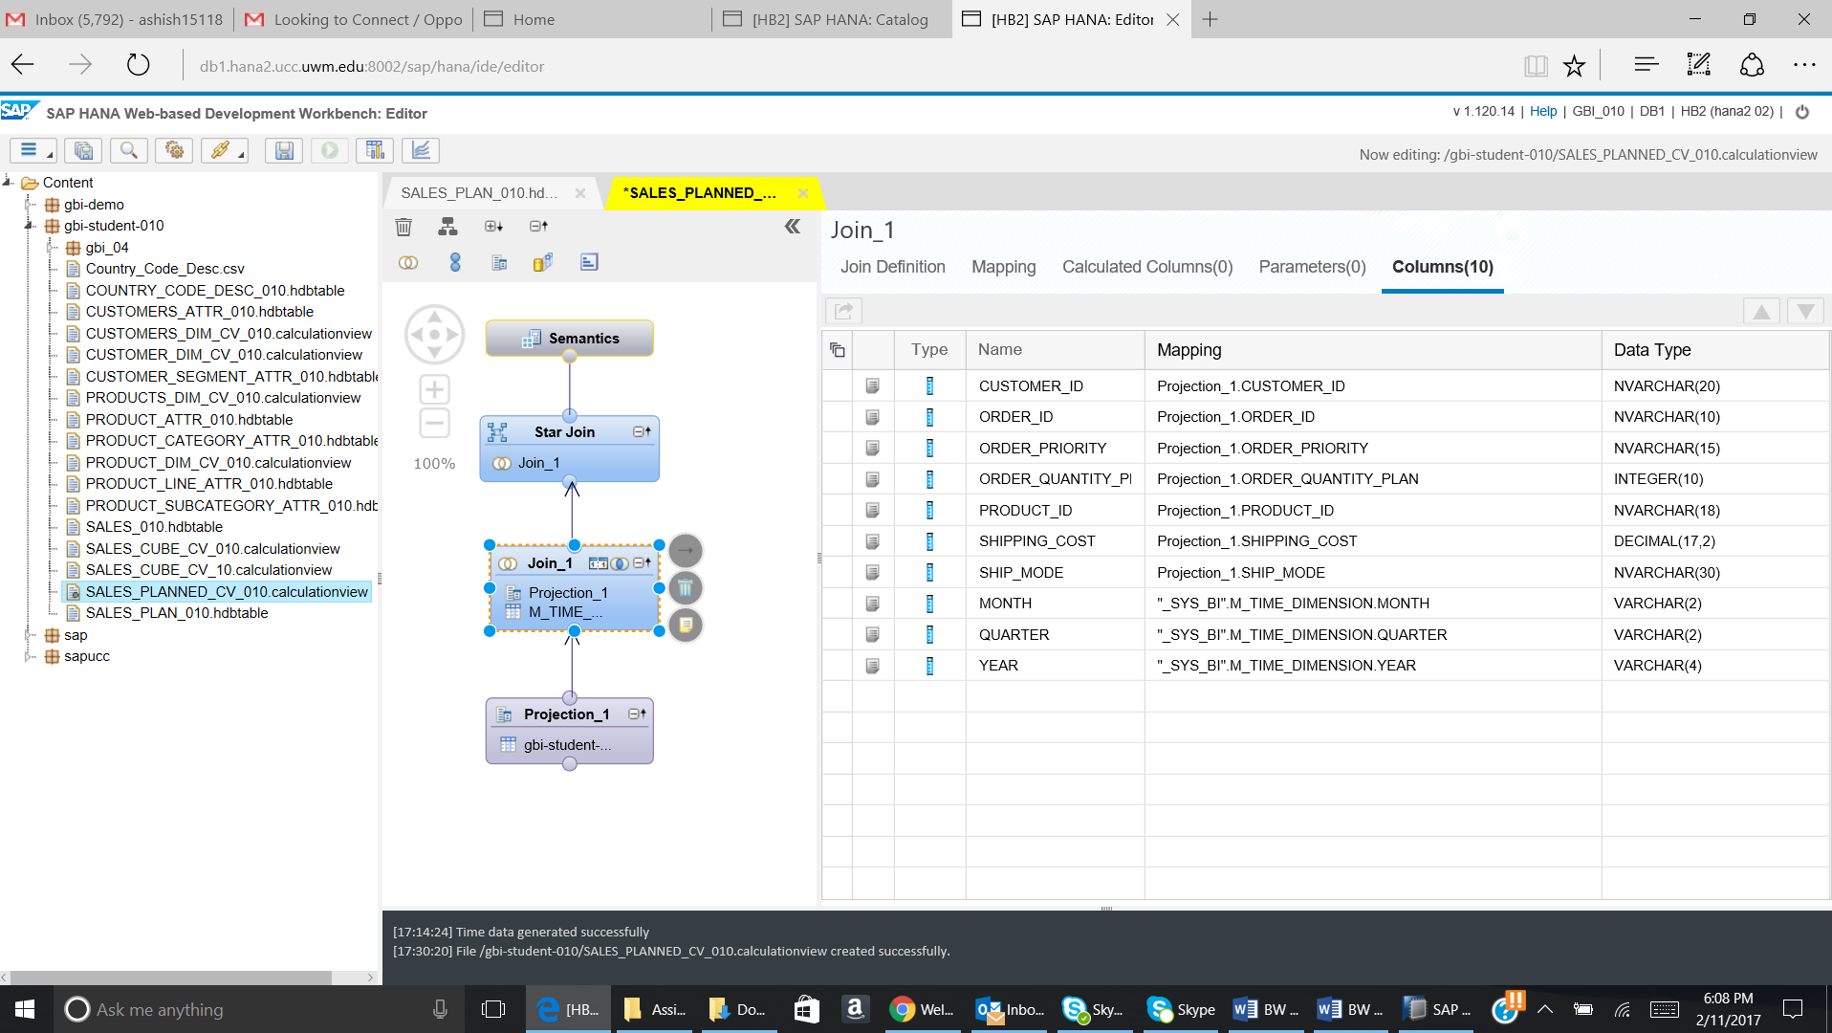

* 1. Click on the Star Join and then + sign will appear. Click on the + sign and pop up will appear.

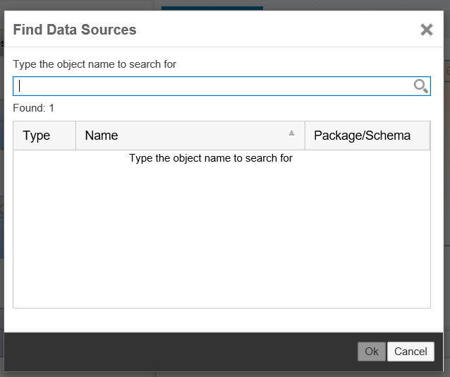

Now search for Customer_Dim_Cv_YYY and then select it and click on OK.

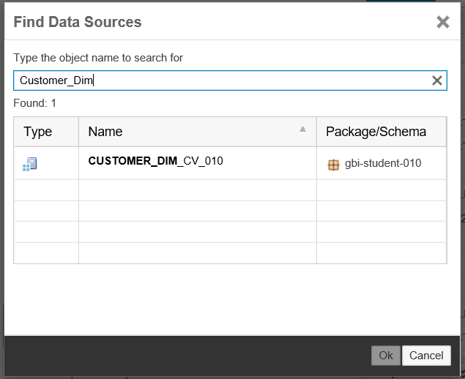

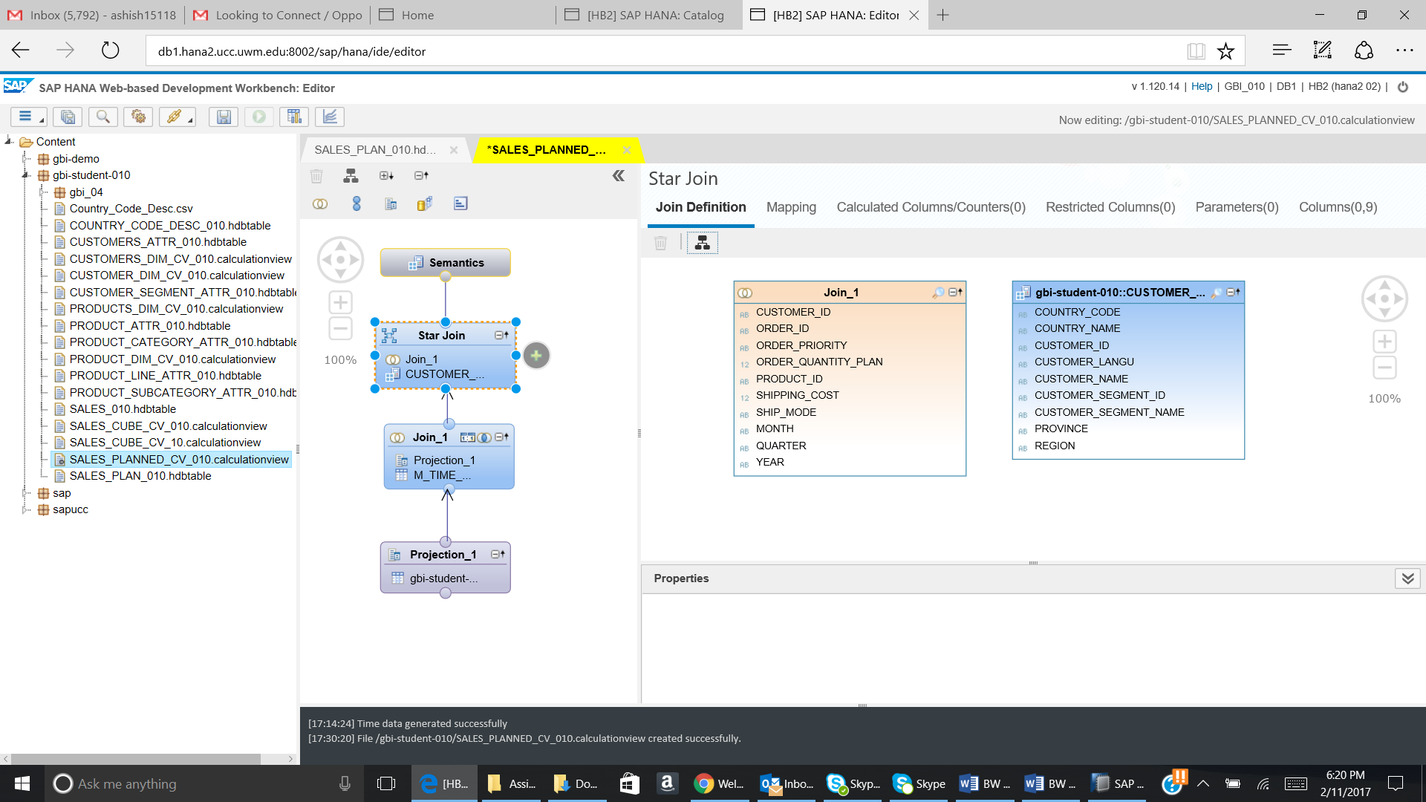

Now again click on + sign and then add Product_Dim_Cv_YYY.

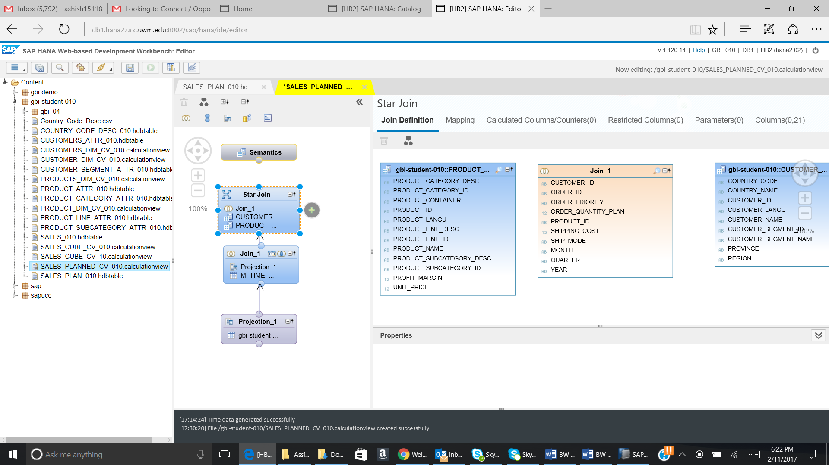

Drag the Customer_Id from the Join_1 to the Customer_Id on gbi-student-yyy.Customer_Dim_Cv_YYY.

Similarly, drag Product_Id from the Join_1 to the Product_Id on gbi-student-yyy.Product_Dim_Cv_YYY.

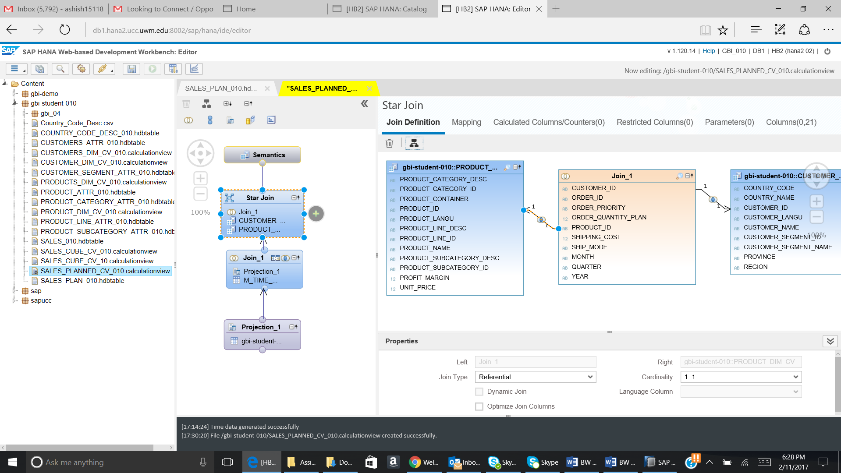

Go to the Mapping tab and then add all the fields to the output.

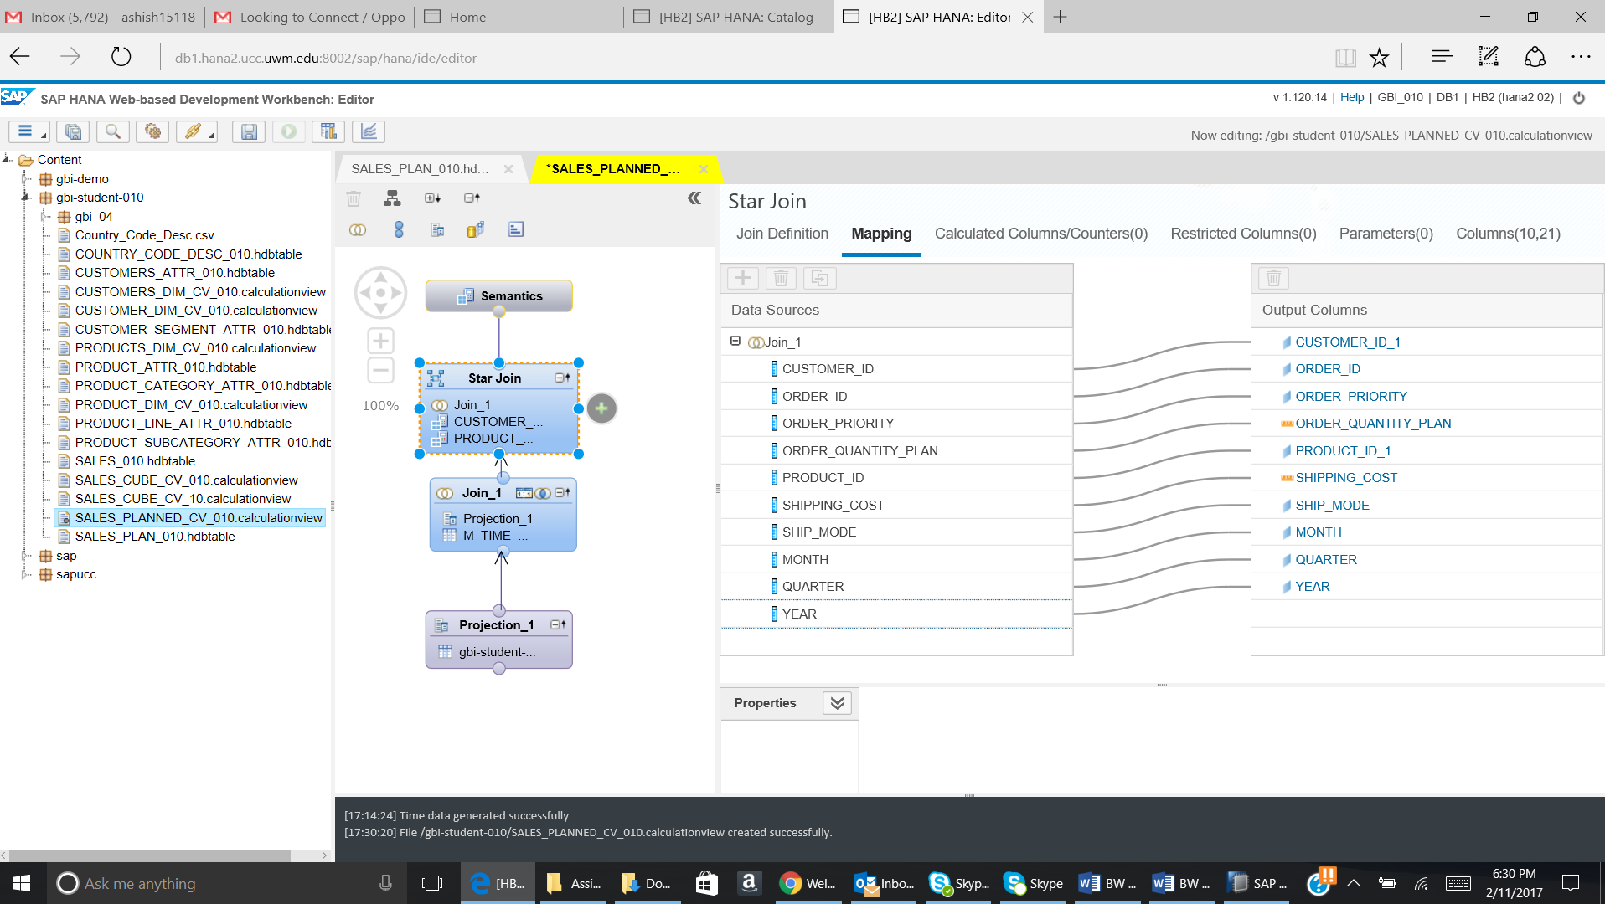

* 1. Add the Calculated Column with the below given details:

**Name:** PLANNED_REVENUE

**Description:** PLANNED_REVENUE

**Formula:** (UNIT_PRICE*ORDER_QUANTITY_PLAN)+ SHIPPING_COST

Go to the Calculated Column Tab.

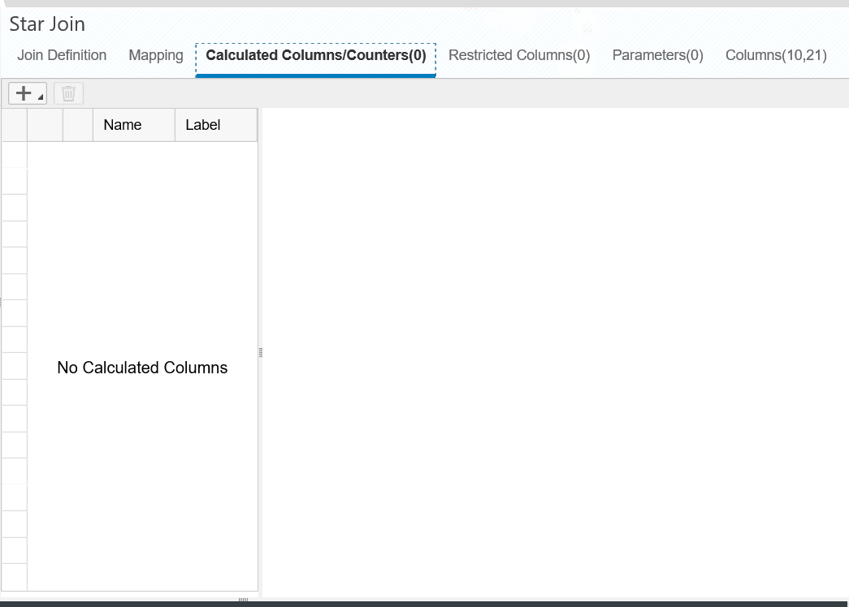

Click on the + sign and then select Calculated Column.

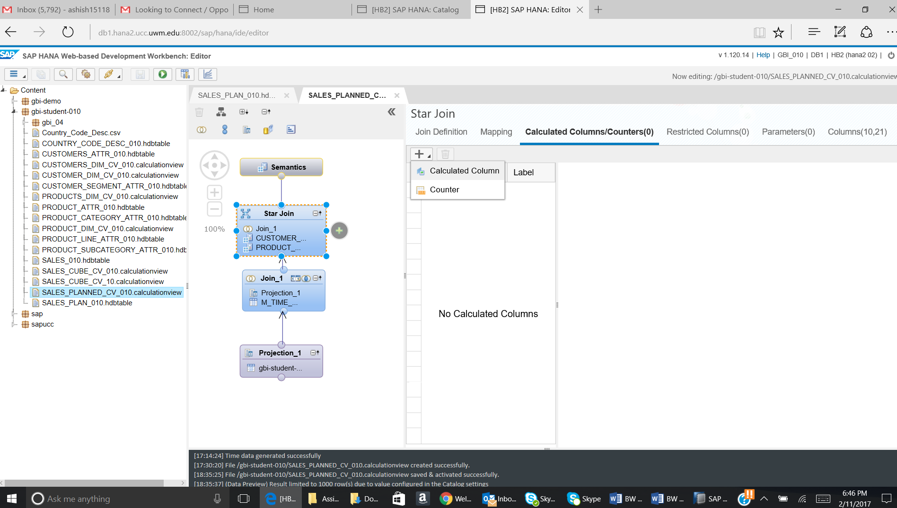

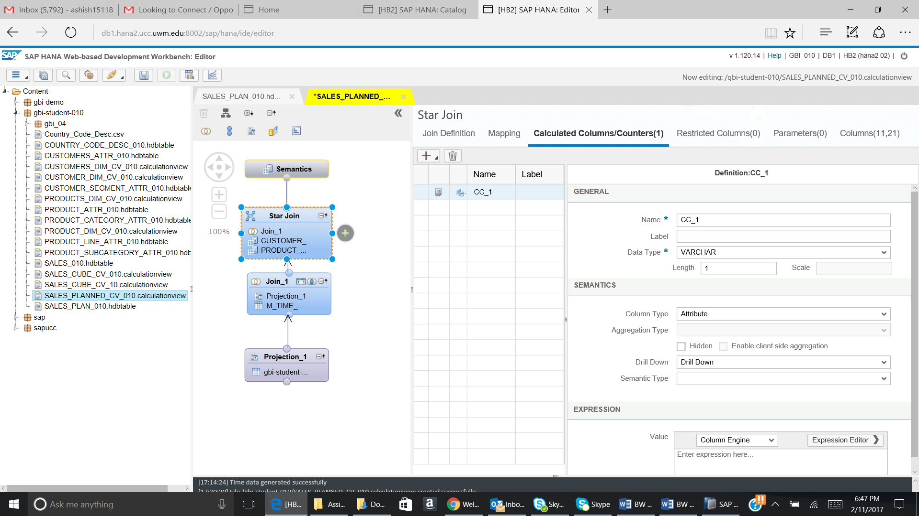

Add the details as given below:

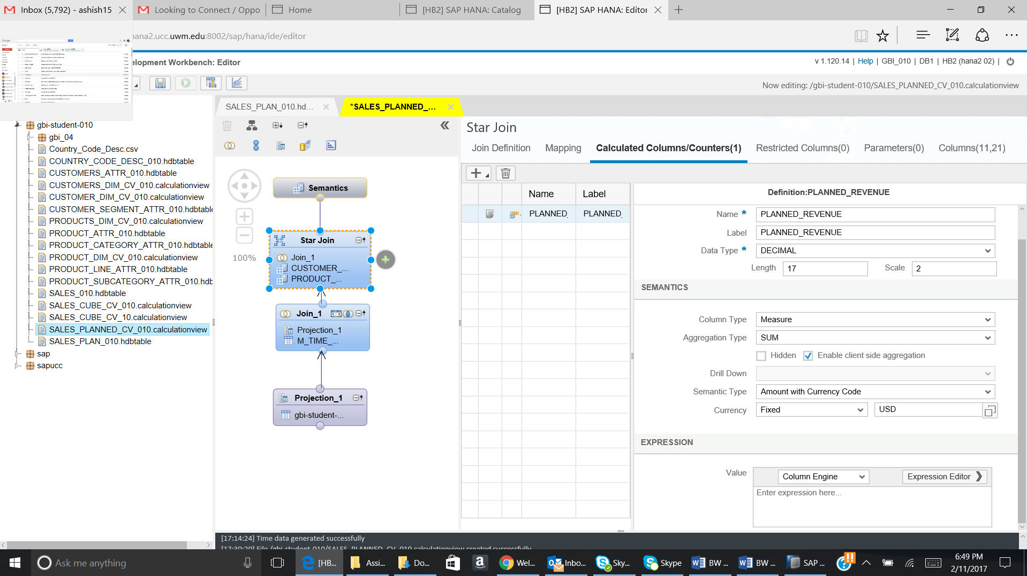

Now click on Expression editor. The below given window will open:

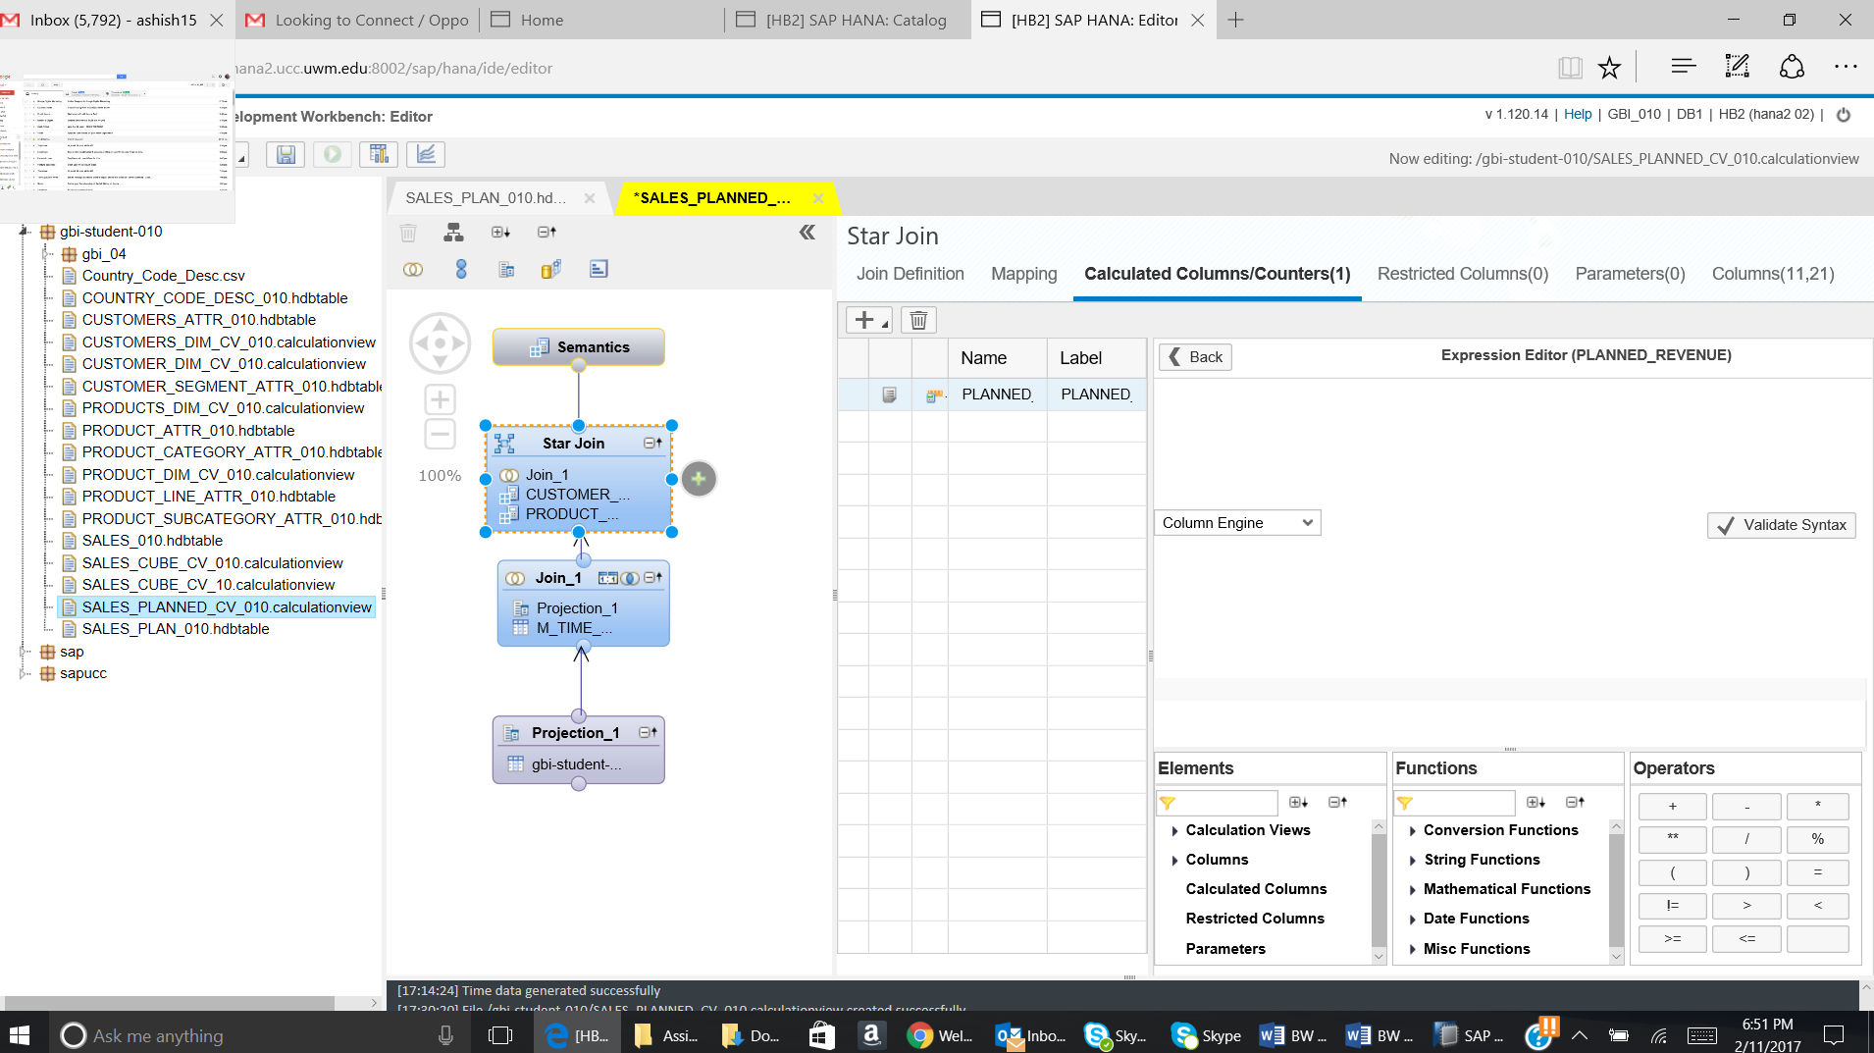

Now enter the expression as given below:

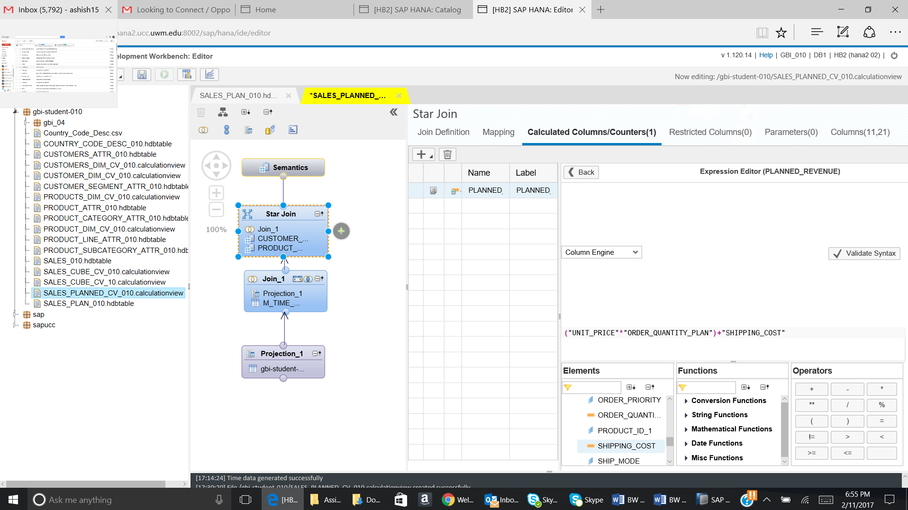

After entering the expression, click on the Back button.

Go to the Columns Tab. You will be able to see the Calculated column created.

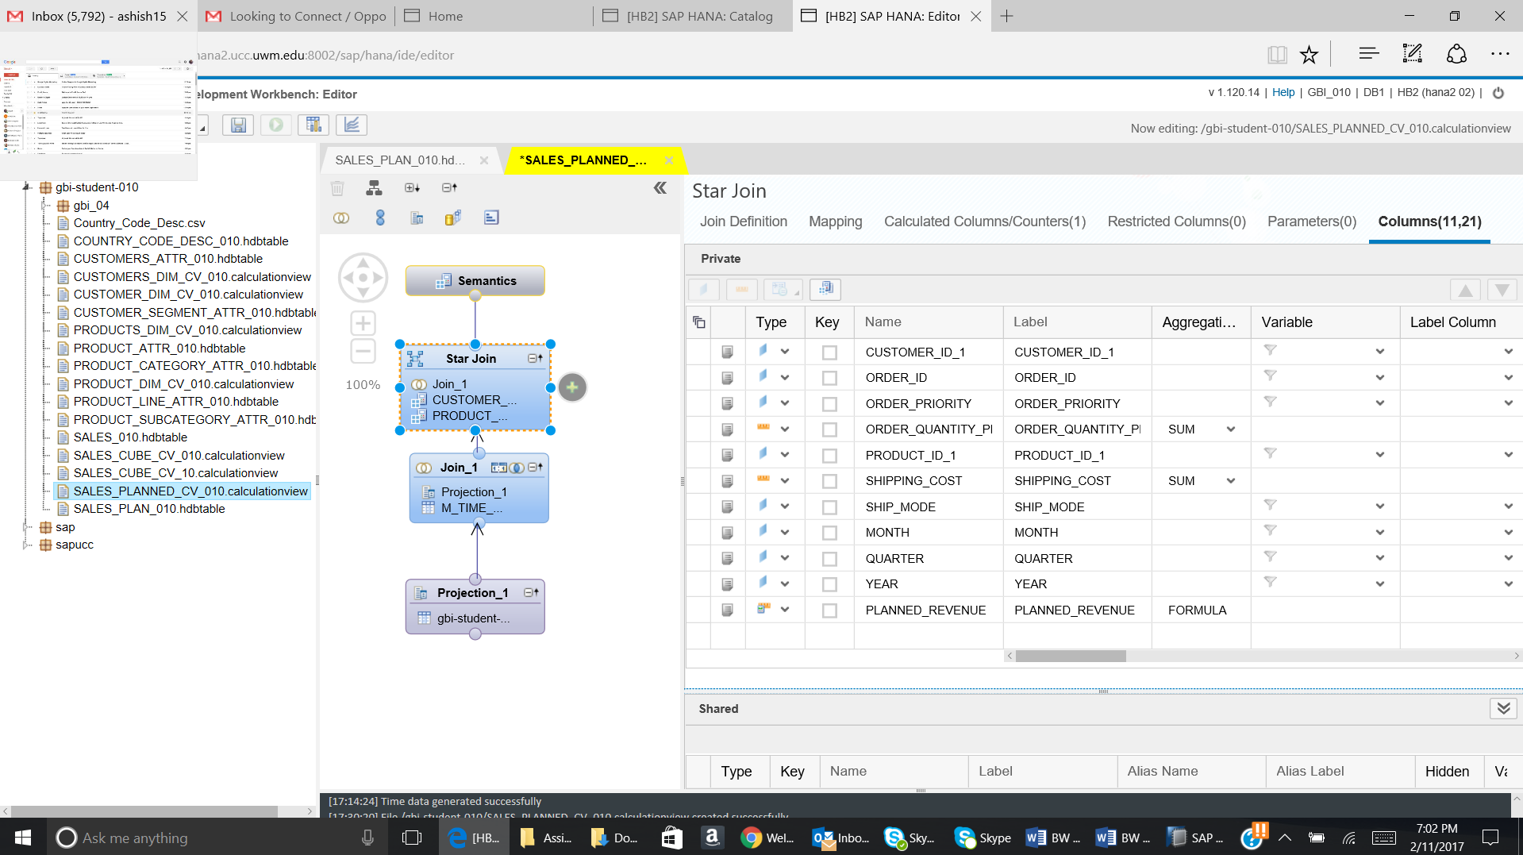

Paste the screenshot of the Columns tab.

Click on Save button. The below given message will come:



Paste the screenshot of the success message.

Now click on Run icon.

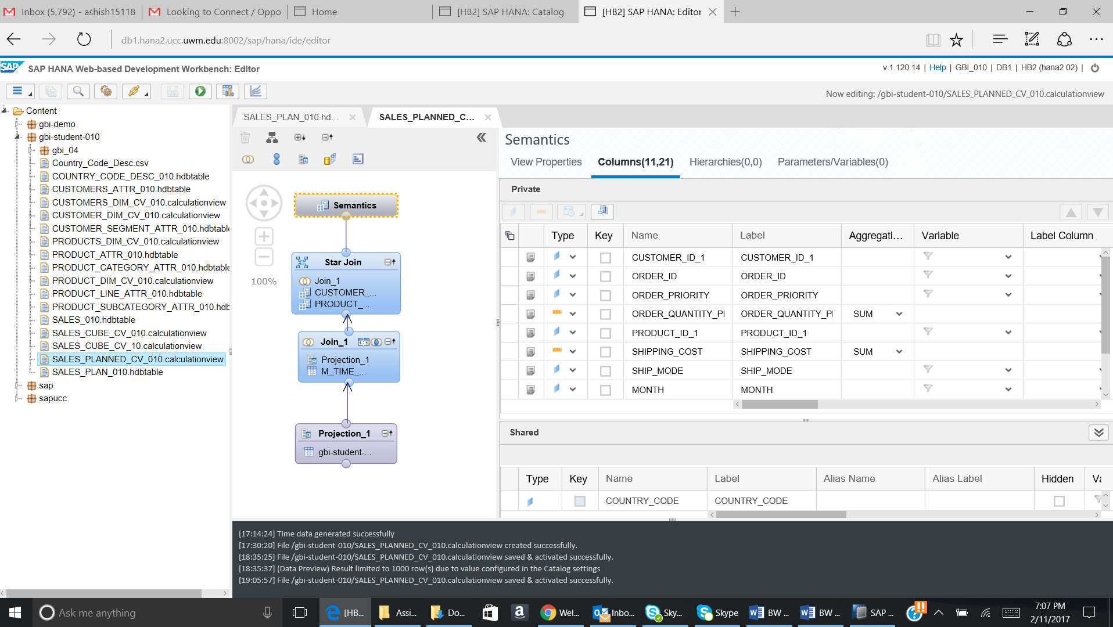

Paste the screenshot of the Data generated.

**5.)** **Creating calculation view**

**Objective:**

The purpose of creating the calculation view is to compare the previously created actual sales cube view and the planned cube view created in this exercise.

**Steps:**

Use following details to create the view:

**View name**: ACTUALREVENUE_VS_PLANREVENUE_CV_**YYY**

**View description**: ACTUALREVENUE_VS_PLANREVENUE_CV_**YYY**

**Views:** SALES_AV_**YYY and** PLAN_AV_**YYY**

5.1) Go to the Editor page. Right click on gbi-student-yyy and then go to New and then click on Calculation View. The below given pop up will come.

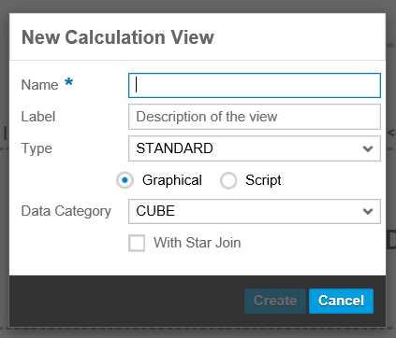

Enter the details in the pop up as given below:

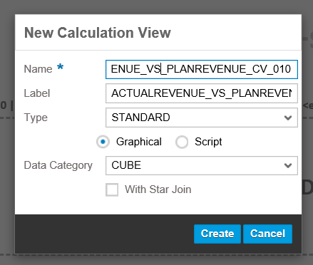

Click on Create. The below given page will open.

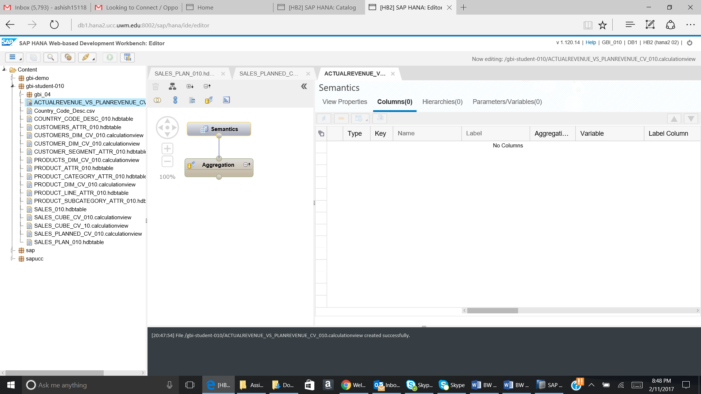

5.2) Add **two projection nodes** to the modelling screen. Add the cube view **SALES_AV_YYY** to the first projection node(**projection_1**) and the cube view **PLAN _AV_YYY** to the second projetion node**(projection_2)**

In oder to add the views to the projection nodes, Click on the **“+”** sign beside the node or right click on the node and select **Add objects.**

Use the following two screen shots for reference.

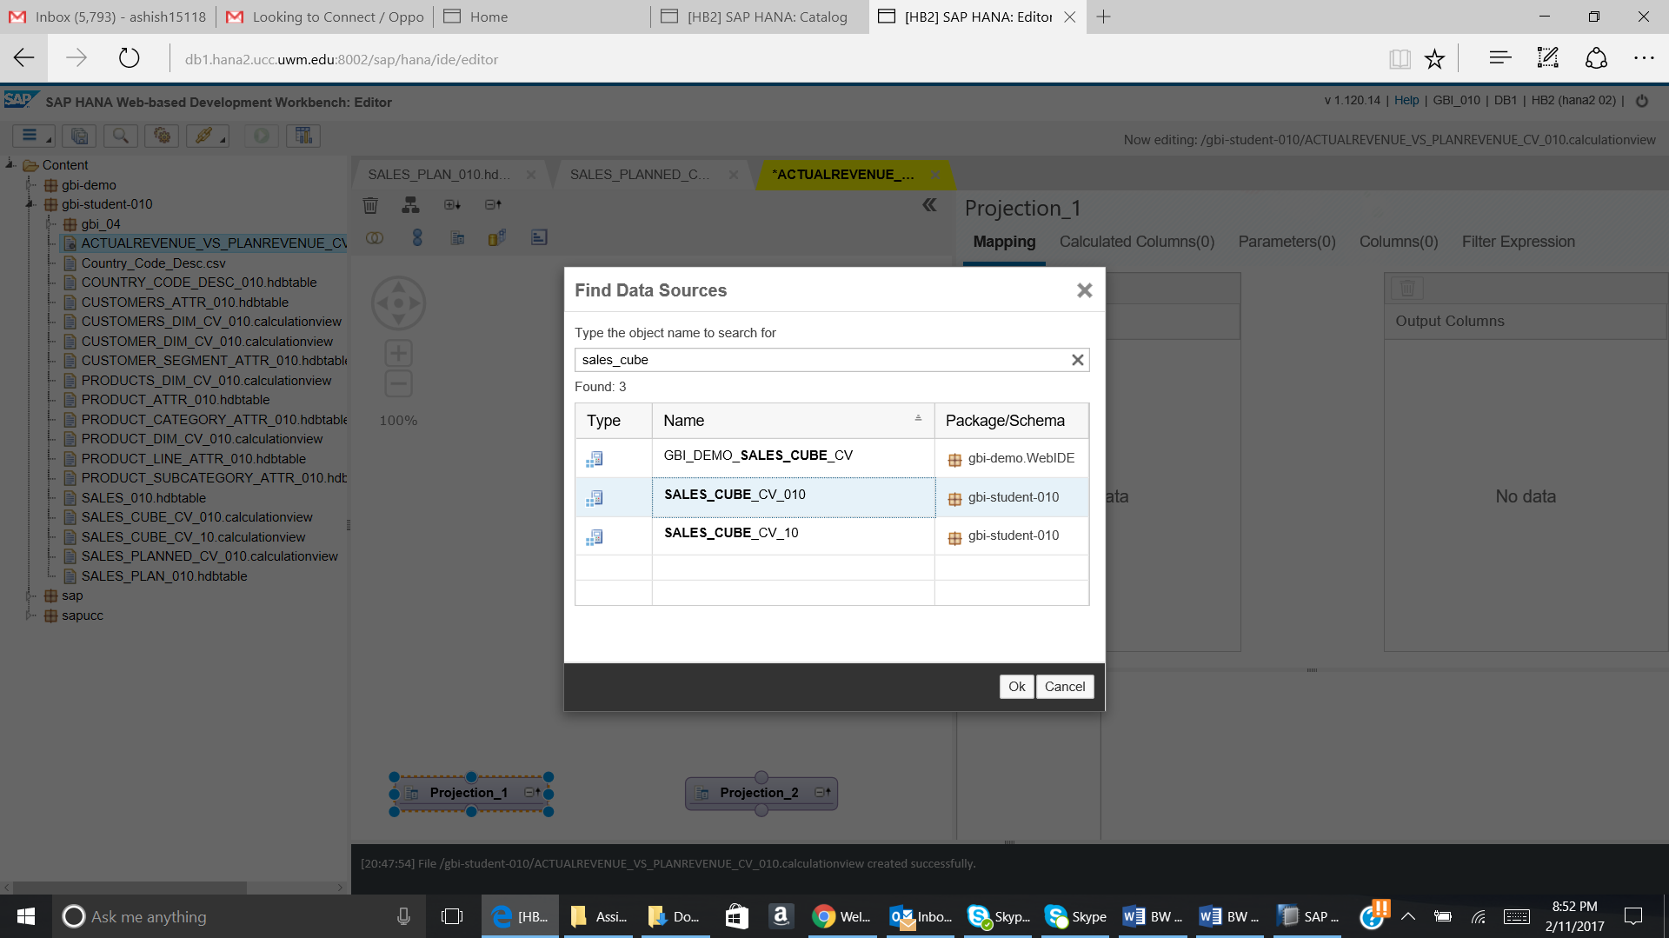

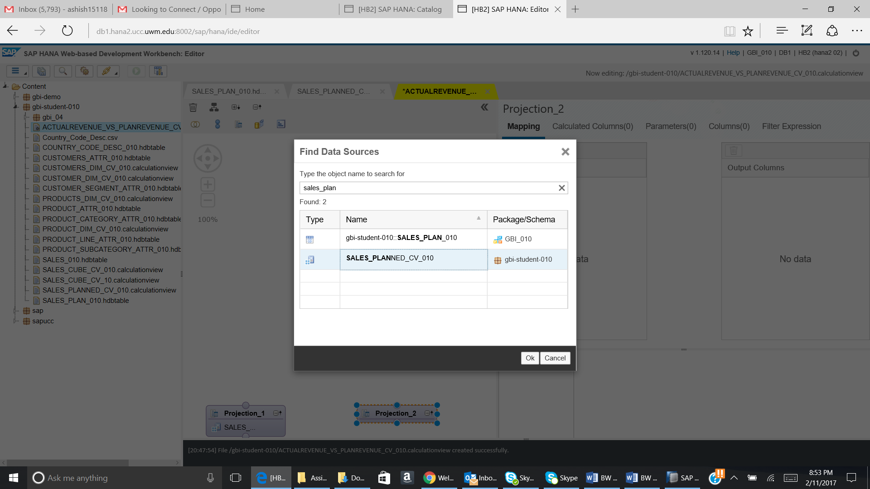

5.3) The **output structure** of the first projection node should be similar to the screen shot below

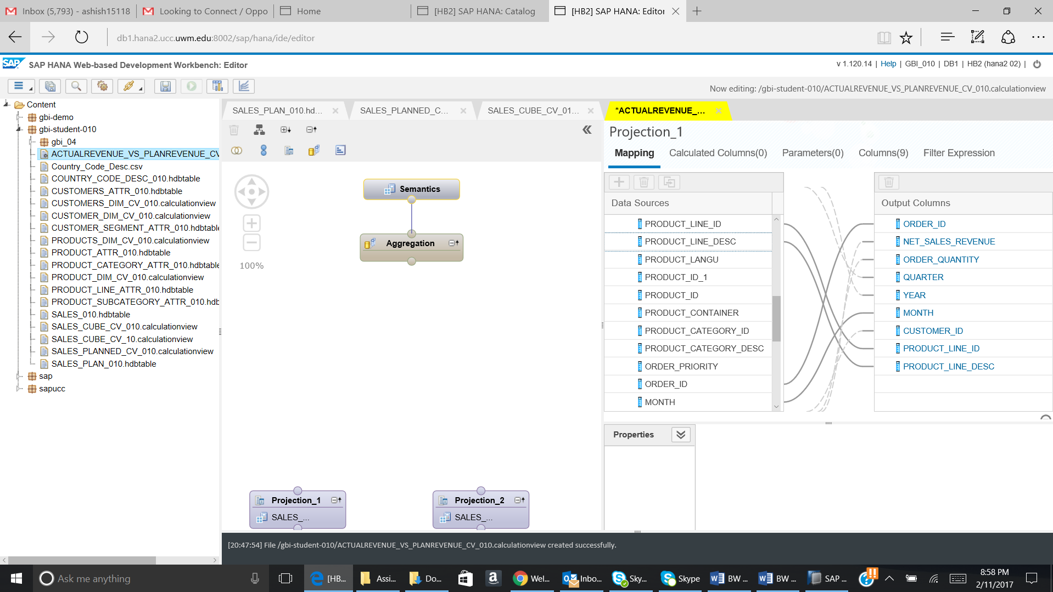

The output structure of the second projection node should be as follows:

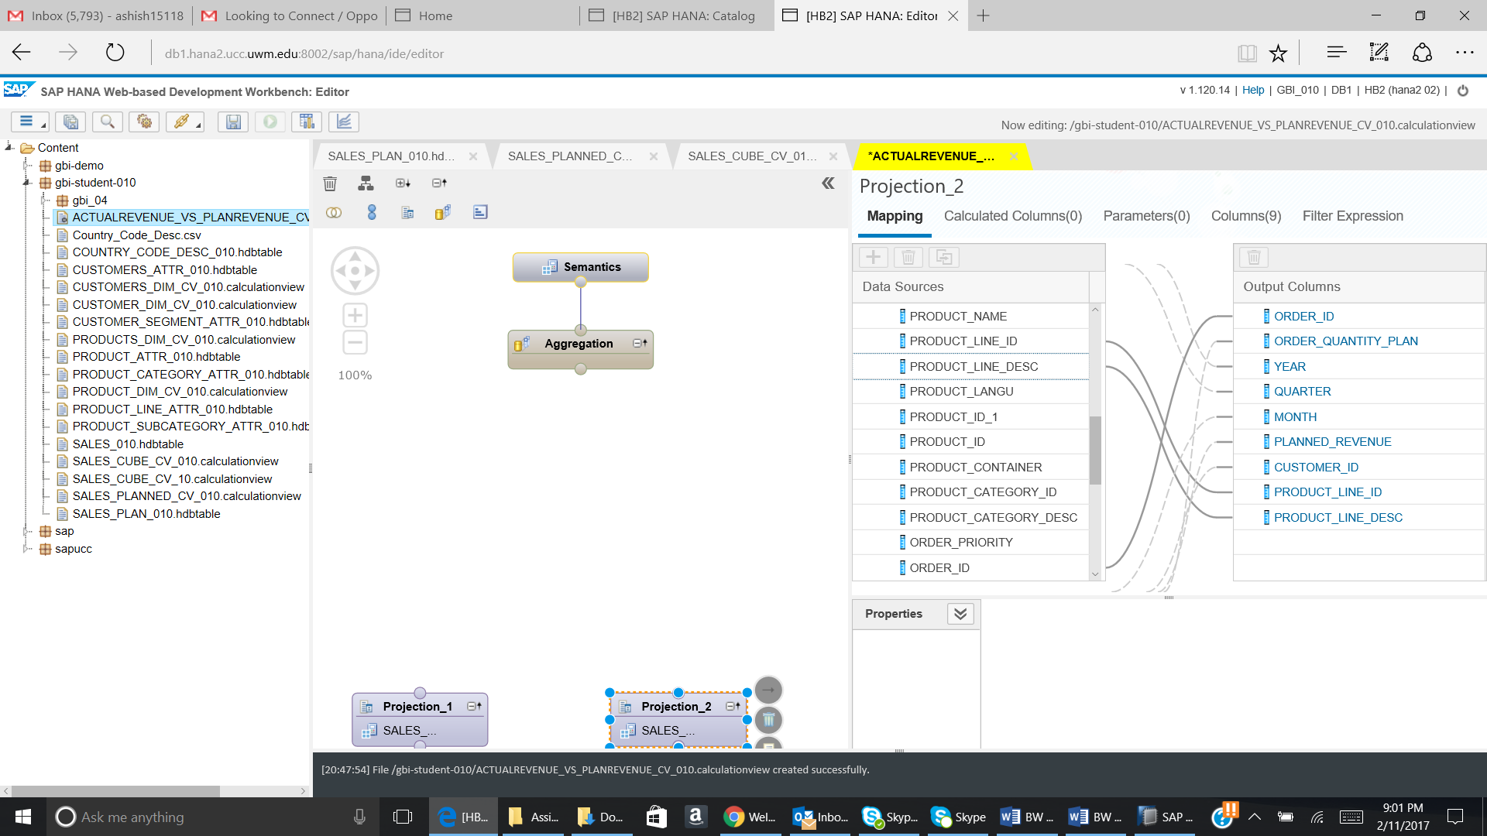

5.4) Go to the filter expression tab.

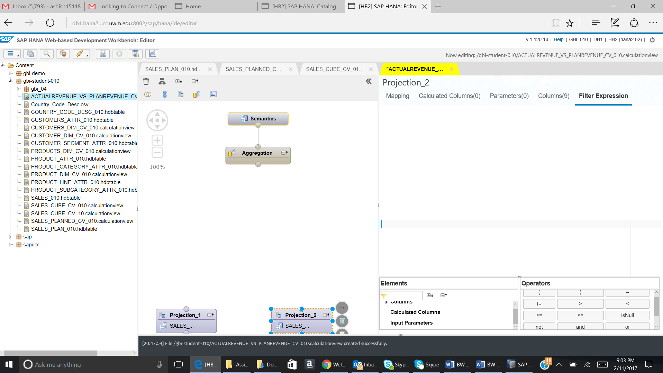

5.5) Enter the expression as shown in the screen shot:

In the **Expression editor** add the formula as shown in the screen shot

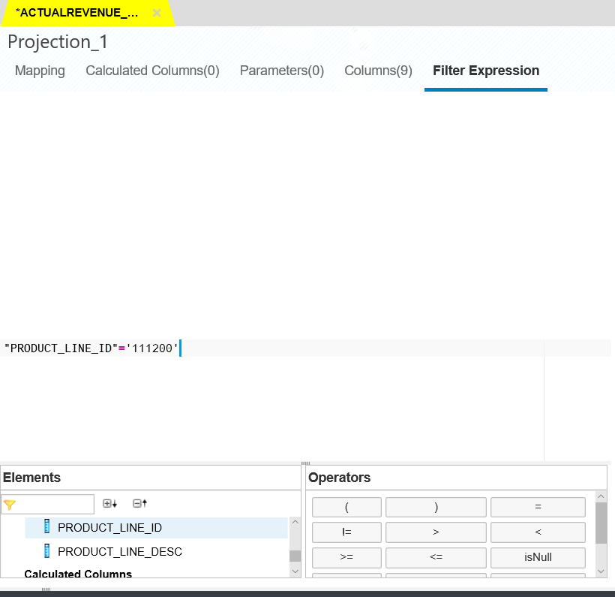

5.6) Similar to the above step create a filter for the second projection node (PLAN_AV_YYY) and add the expression **"PRODUCT_LINE_ID"** ='111200'

**e.) Question**

**Paste the screen shot of the expression editor for the second projection node (PLAN_AV_YYY)**

**______________________________________________________________________________**

5.7) Add aggregation node to the modelling window and connect **projection_1** node to it. Drag and drop the arrow from **the projection_1** node to the aggregation node inorder to join them

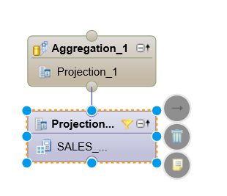

The output structure of the **aggregation_1** node should be as shown in the screenshot:

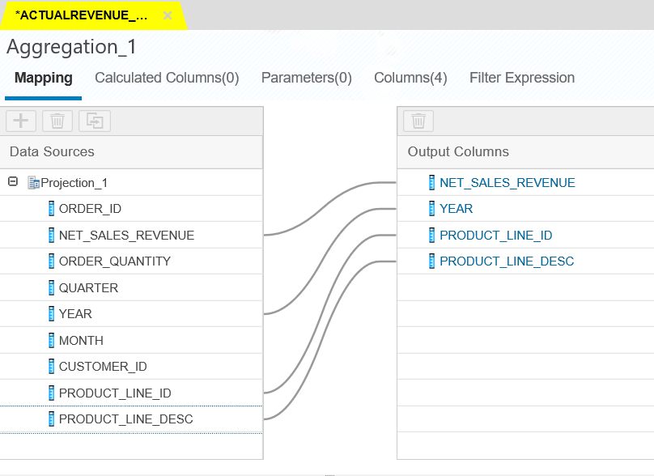

Click on Columns tab and then select the Aggregation value for Net_Sales_Revenue as SUM.

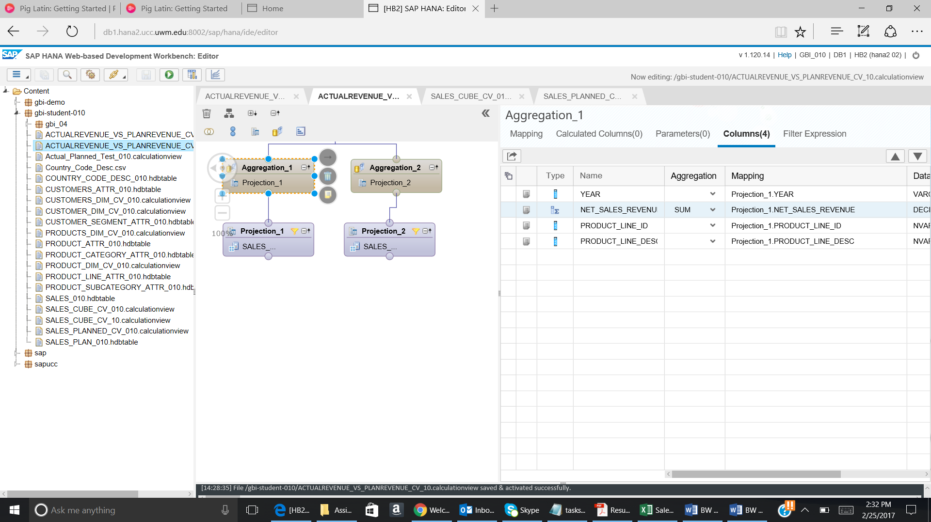

5.8) Similarly add aggregation node to projection_2 node and the output structure of it should be as shown in the screenshot:

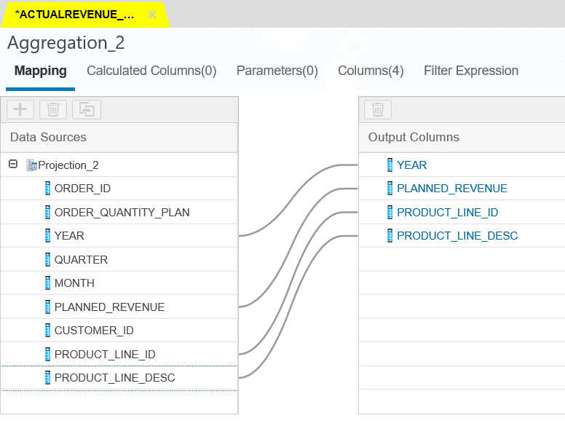

Click on Columns and select Aggregation value for Planned_Revenue as SUM.

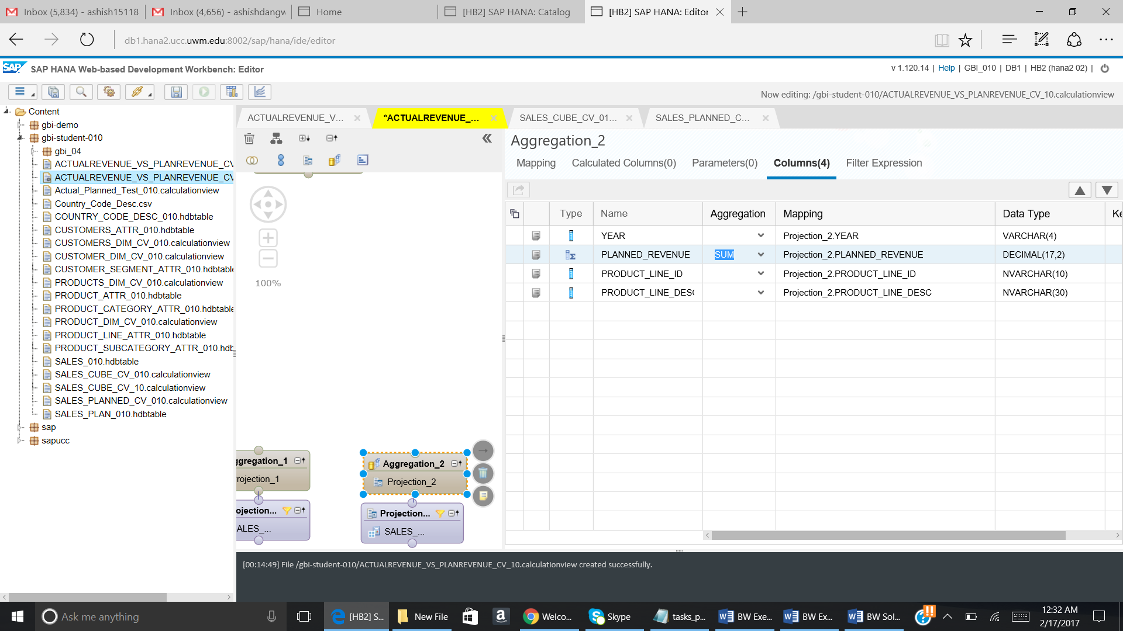

5.9) Drag and drop a **join** node to the modelling window and connect **aggregation_1** and **aggregation_2** to it

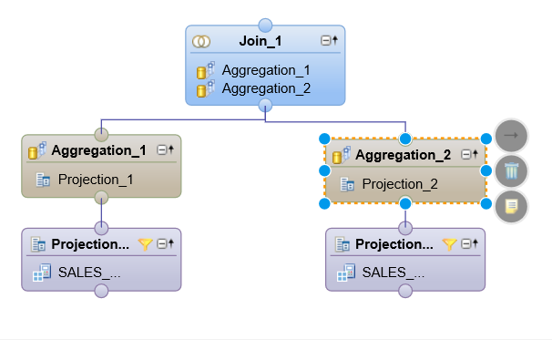

Join **aggregation_1.year** to **aggregation_2.year** using an inner join.

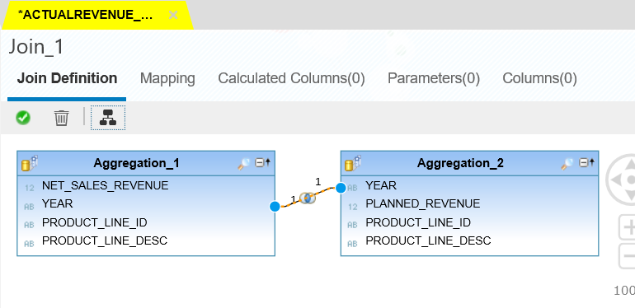

Add the following fields to the output:

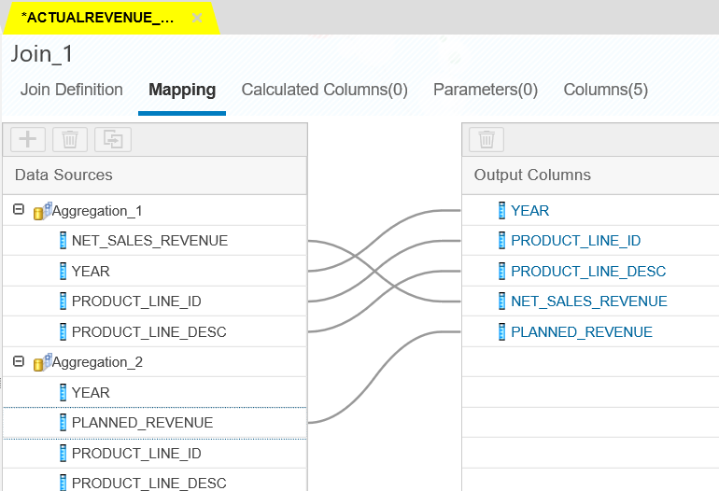

5.10) Go to the Calculated Column Tab.

Use following details to create the new calculated measure:

**Name**: precentage_growth

**Description:** percentage_growth

**Data type** : Decimal

**Formula:** round(("PLANNED_REVENUE" -"NET_SALES_REVENUE" ) /"NET_SALES_REVENUE",2)

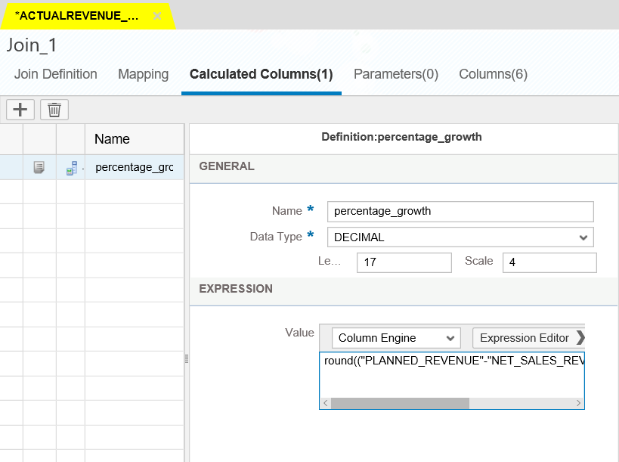

Add another calculated column and use the following details:

**Name:** integer_year

**Description:** integer_year

**Data type :** Integer

**Formula:** **int**(**"YEAR"**)

This step is performed to convert the years into integer values

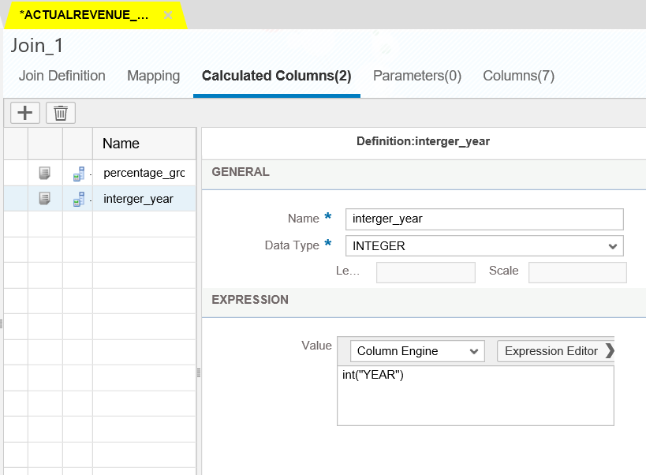

Go to column tab. The below given columns will be shown:

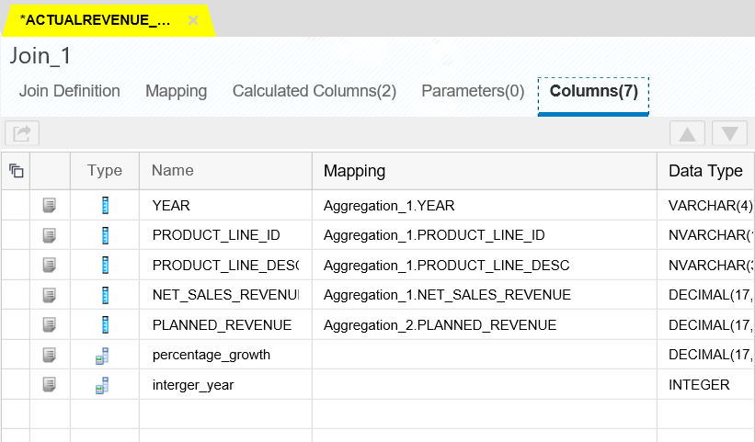

5.11) Drag and drop **aggregation node** and connect **Join_1** node to it. This step is performed to aggregate the percentage_growth.

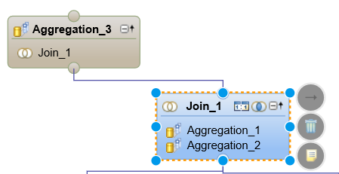

.

5.12) Add **product_line_id, Product_line_description and percentage_growth** to the output

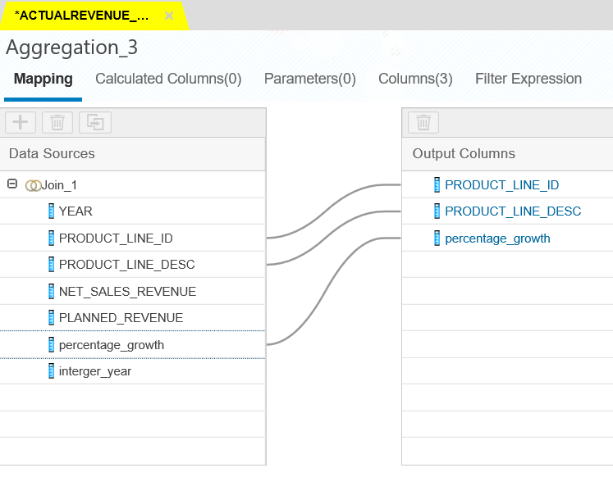

5.13) Add a new calculated column and use the following details:

**Name:** newyear

**Description:** newyear

**Data type** : Integer

**Formula:** **2027**

This step is performed to introduce a new year 2027 as we will be calculating the revenue for this year using the 2026’s revenue and average of growth rate

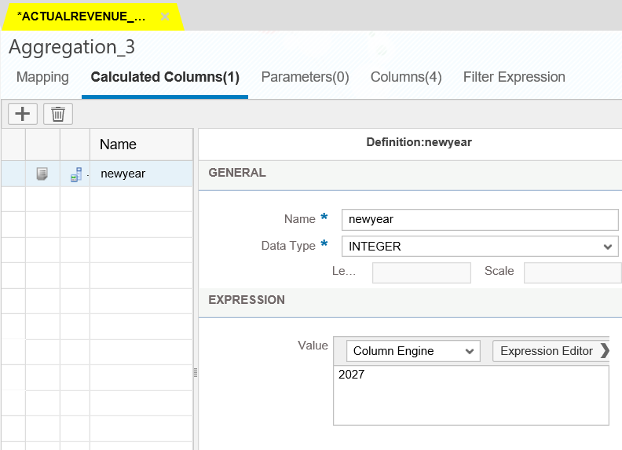

The output structure of the **aggregation_3** node should be as follows:

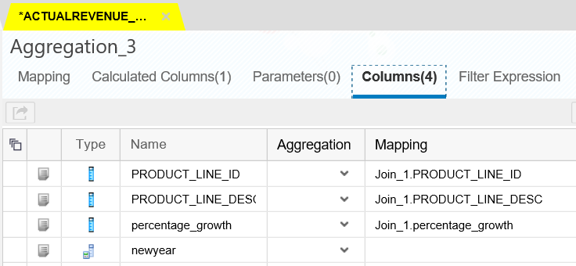

5.14) Drag and drop a **projection node** and connect **aggregation_3** node to it

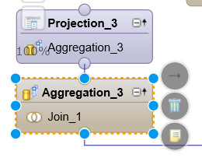

5.15) Add **percentage_growth, Product_line_desc, product_line_id and newyear** to the output

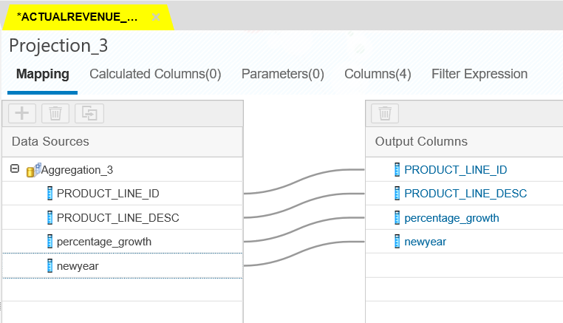

5.16) Create a new calculated column and use the following details:

**Name:** average

**Description:** average

**Data type :** decimal length :17 scale : 4

**Formula:** **round**(**"percentage_growth"**/6,2)

This step is performed to find out the average of the growth rate.

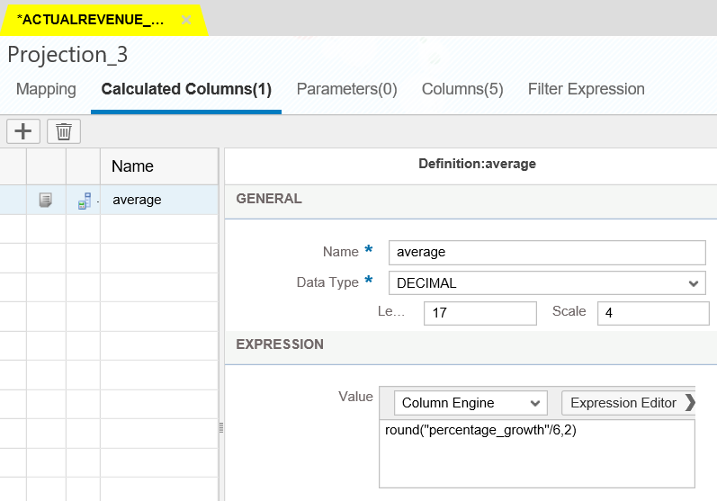

5.17) Create another calculated column, use the following details:

**Name:** joinyear

**Description:** joinyear

**Data type :** Integer

**Formula:** **2026**

This step is performed to add a joining condition using the year 2026, because we use 2026 year’s revenue for the calculation of 2027’s revenue

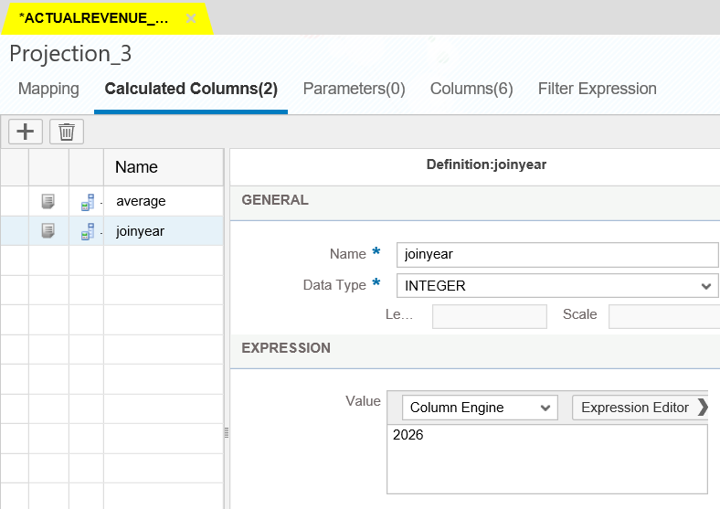

The output structure of **projection_3** node should like the one shown in the screenshot

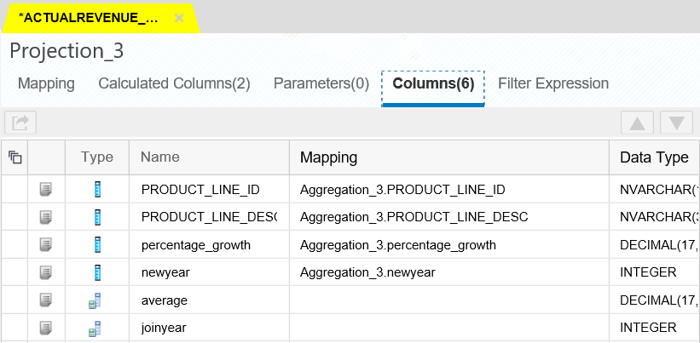

5.18) Drag another **join** node and connect **projection_3** and **join_1** node to it

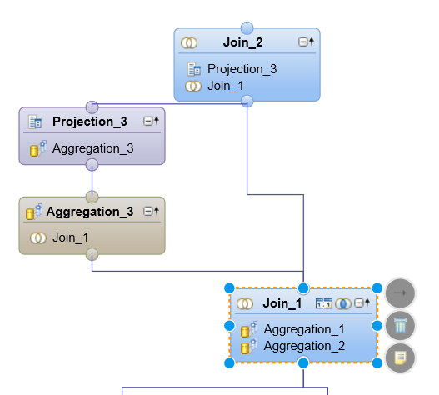

5.19) Join **projection_3.joinyear** to **join_1.integer_year** using an **inner join**

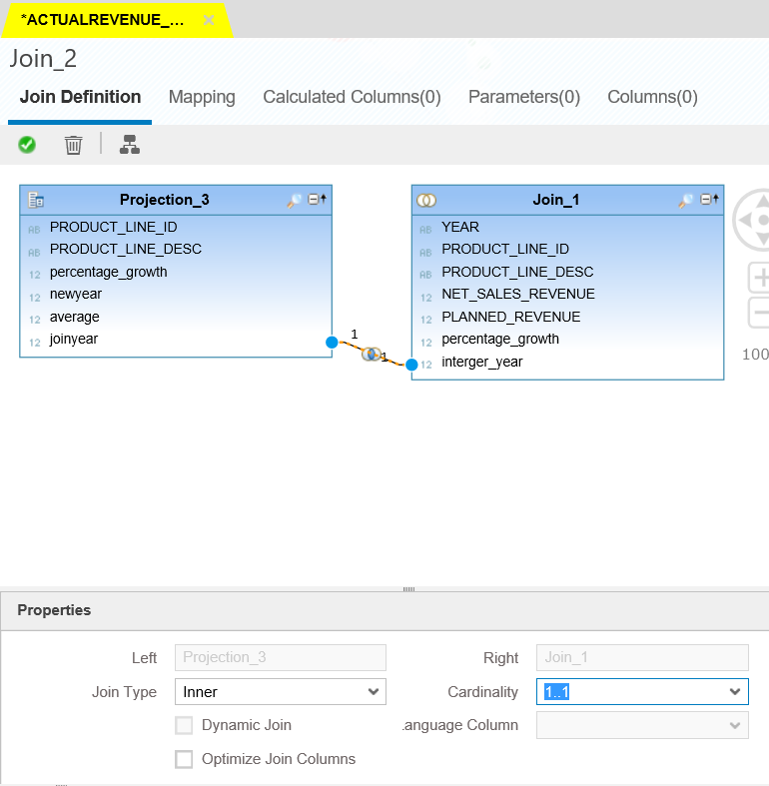

The output structure of **join_2** node should be as follows:

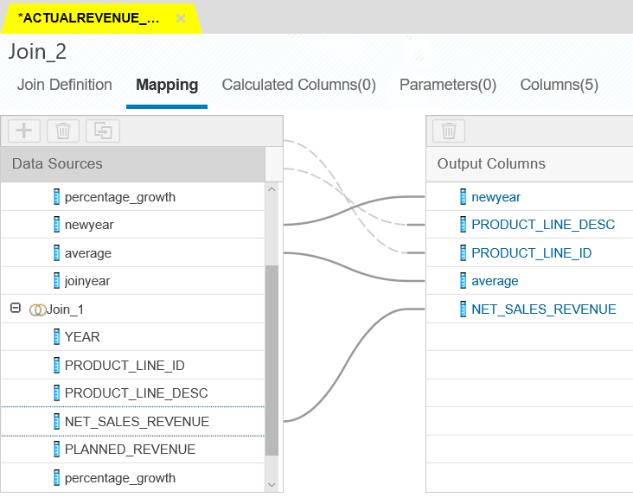

5.20) Drag another **projection** node and connect node **join_2** to it.

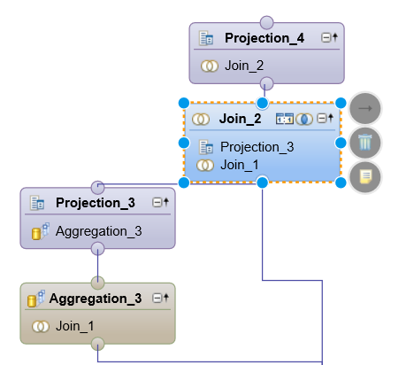

5.21) Add **newyear, product_line_id, product_line_desc, average and net_sales_revenue** to the output.

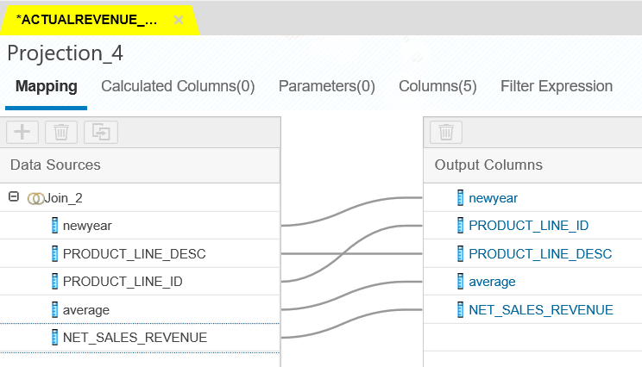

5.22) Create another calculated column, use the following details:

**Name:** revenue_2027

**Data type :** decimal length : 17 Scale :4

**Formula:** (**"average"**) *(**"NET_SALES_REVENUE"**)

This step is performed to calculate the revenue for the year 2027

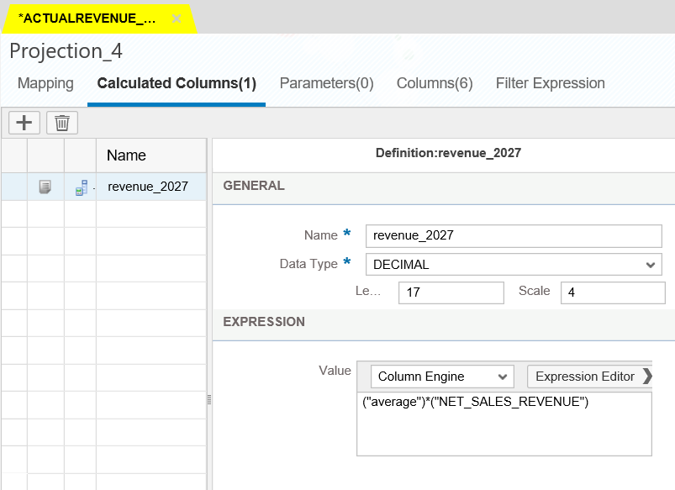

5.23) Create another calculated column, use the following details:

**Name**: yearnew

**Data type** : varchar length :4

**Formula:** 2027

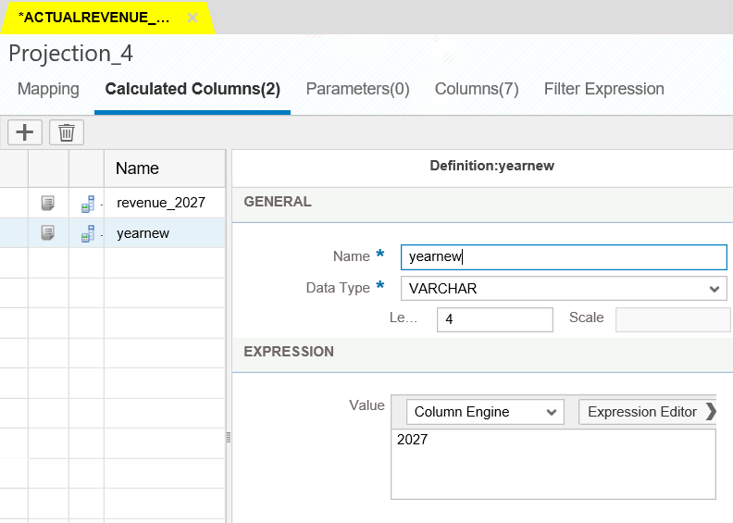

The output structure of **projection_4** node should be similar to screen shot.

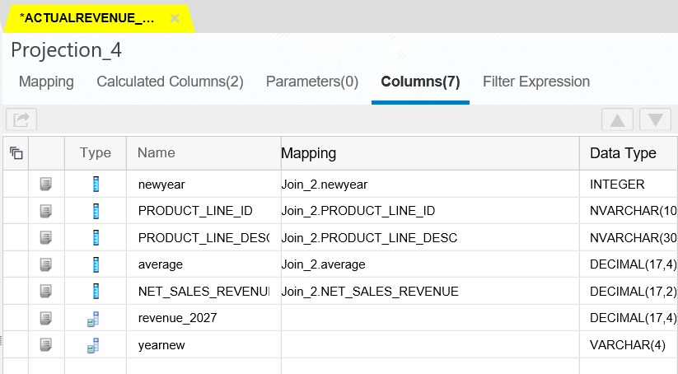

5.24) Drag a **union** node and connect **join_1** node and **projection_4** node to it.

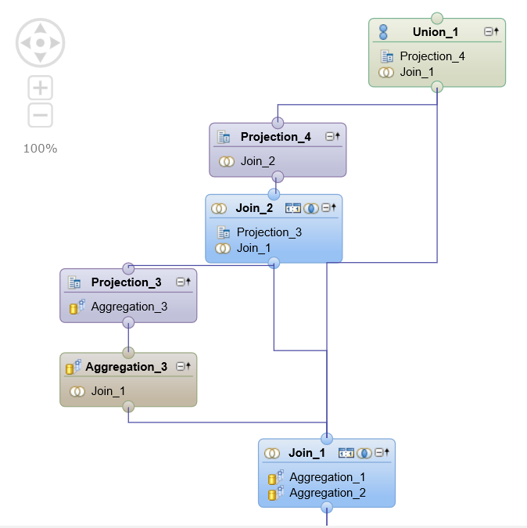

5.25) Drag and drop fields from the source field to the target field as per the screen shot below:

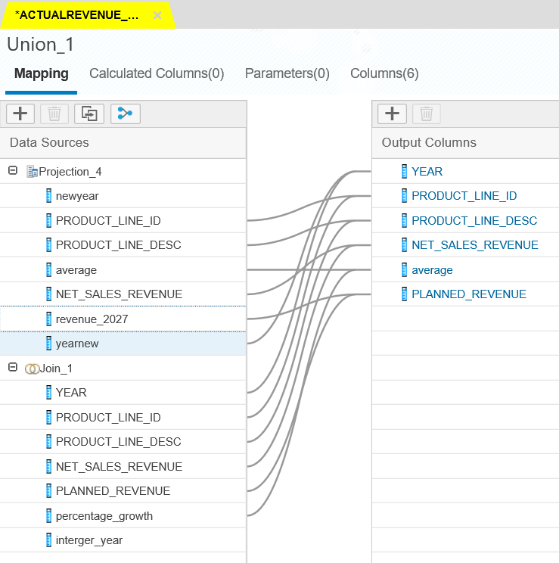

5.26) Connect **union_1** node to the aggregation node connected to the semantics

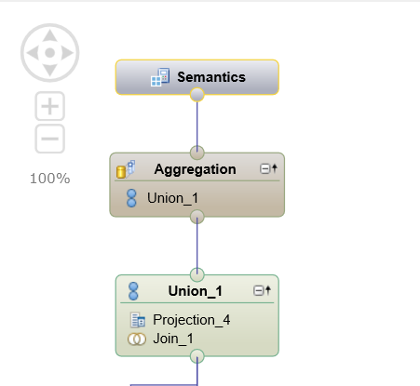

Perform the mapping of the final aggregation node as given below:

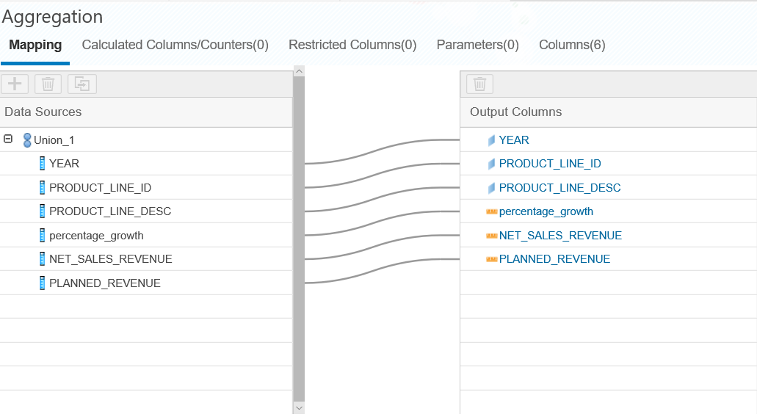

**Note: Finally, your model should look similar to the below screen shot:**

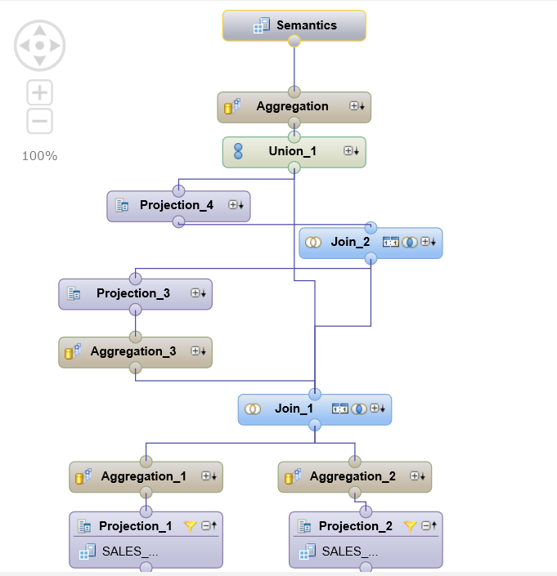

5.27) Click on the semantics tab. It should look as given below:

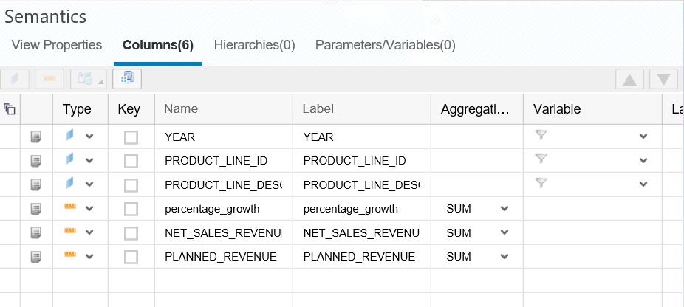

**f.) Question: Paste the screen shot of the semantics tab of the calculation view**

5.28) Click on Save. The success message will come as given below:



**g.) Question: Paste the Screen shot of the status message after activation**

**_____________________________________________________________________**

**h.) Click on the run button present on the left top and paste the screen shot of your raw data of your view**

**____________________________________________________________________**

**6.) Analysis**

We are going to do Analysis with the help of SAP Lumira. Before opening the SAP Lumira, we will first make our cube compatible with SAP Lumira. This is a temporary workaround. This step might become obsolete in the future. Open the calculation view in the text editor.

Right click on calculation view. Go to Open with and then select Text Editor.

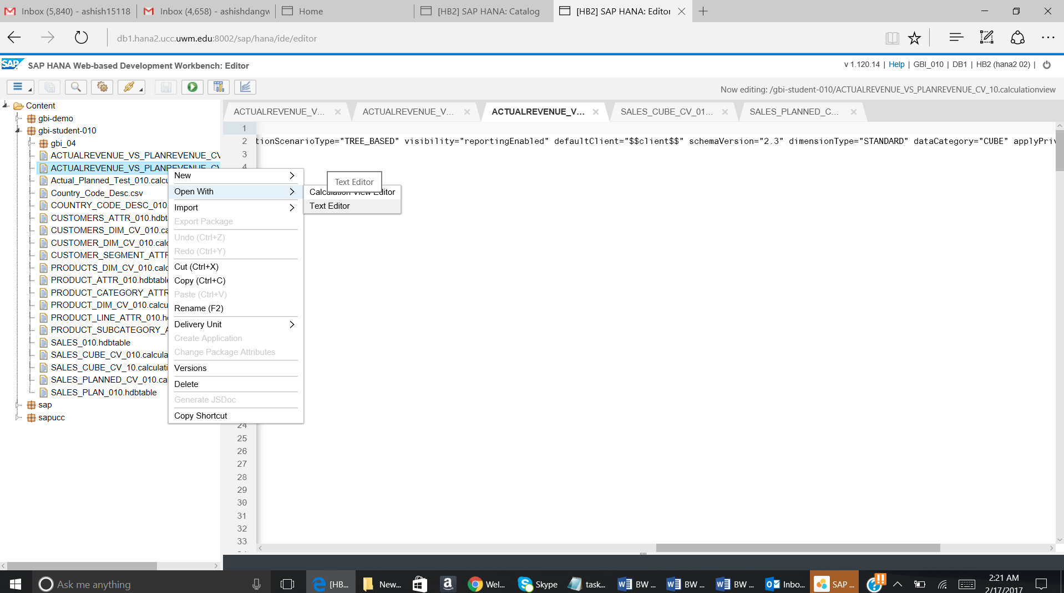

The xml file will open. Go to the second line and then remove dimensionType = “STANDARD”.

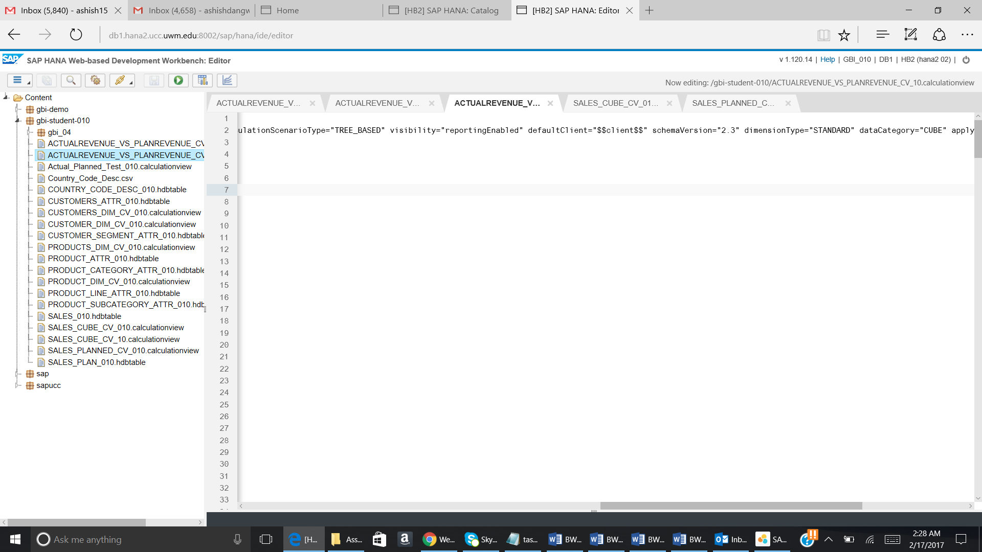

Open the desktop app of the SAP Lumira. Go to file and click on New.

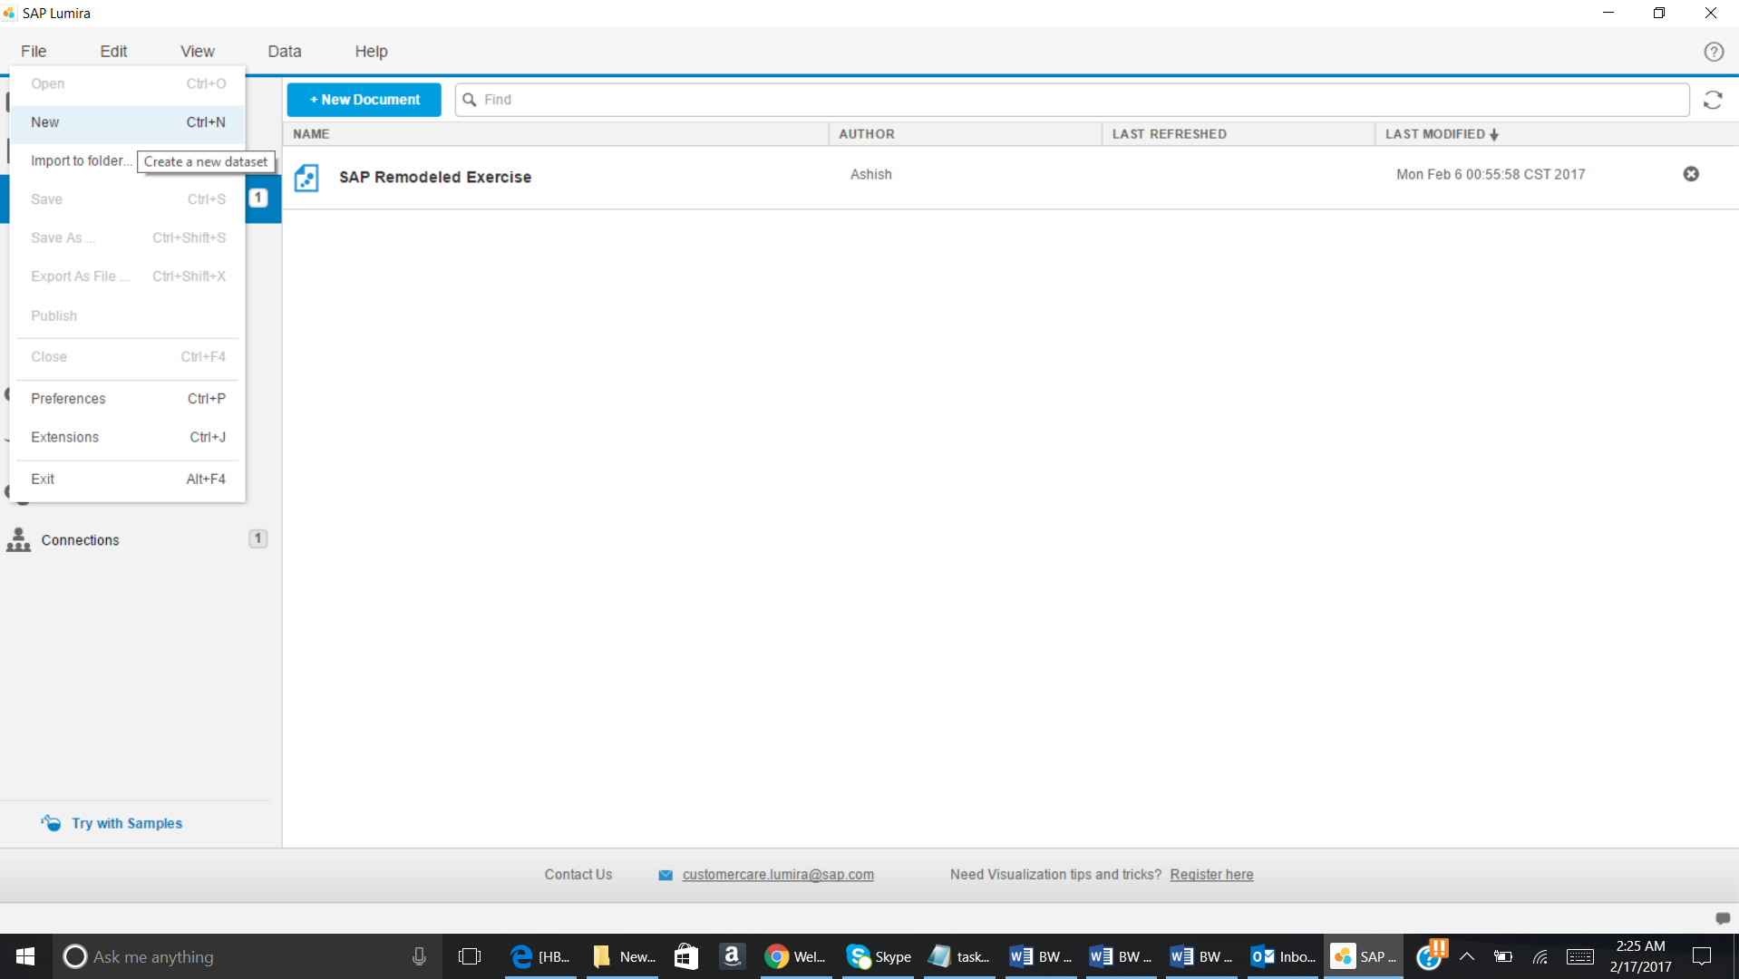

Now select connect to SAP HANA and click on Next.

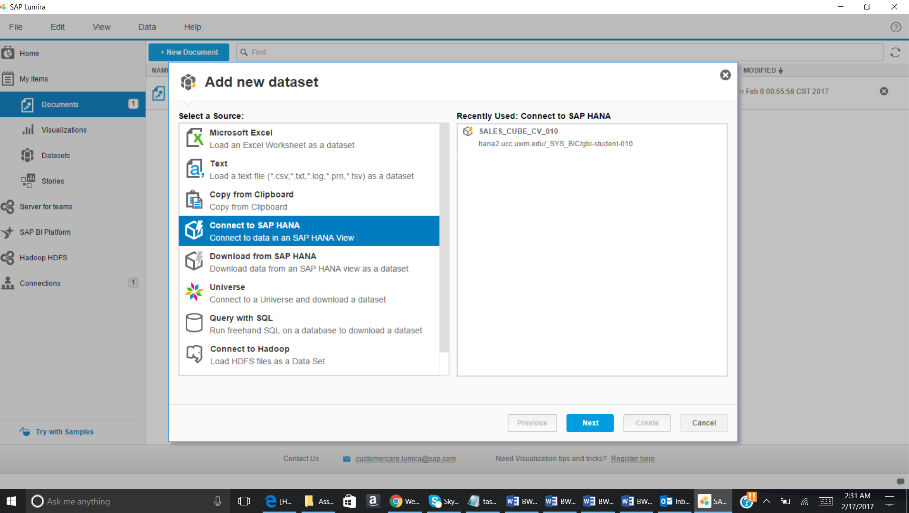

Make the selection as given below:

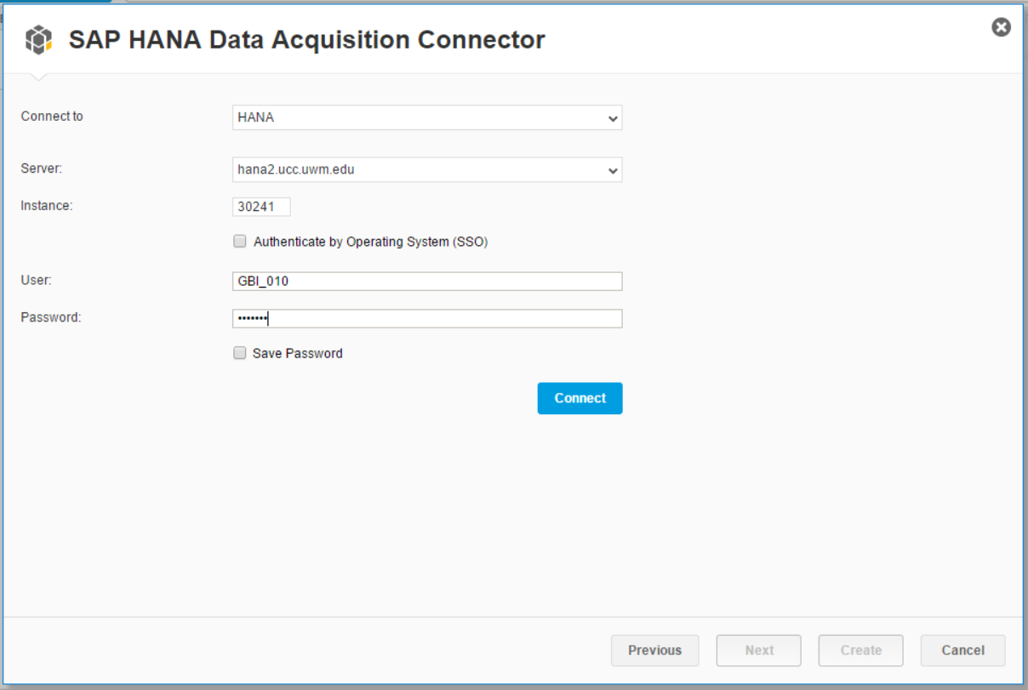

Click on Connect.

Now find the Calculation View which we have created (ACTUALREVENUE_VS_PLANREVENUE_CV_YYY.calculationview).

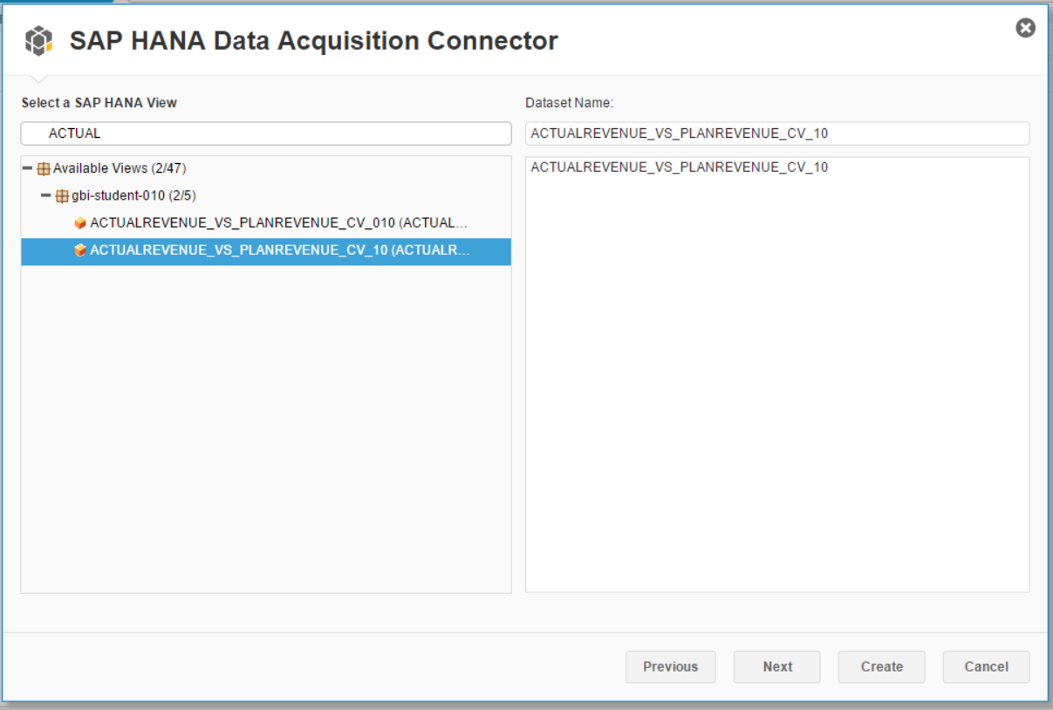

Click on Next.

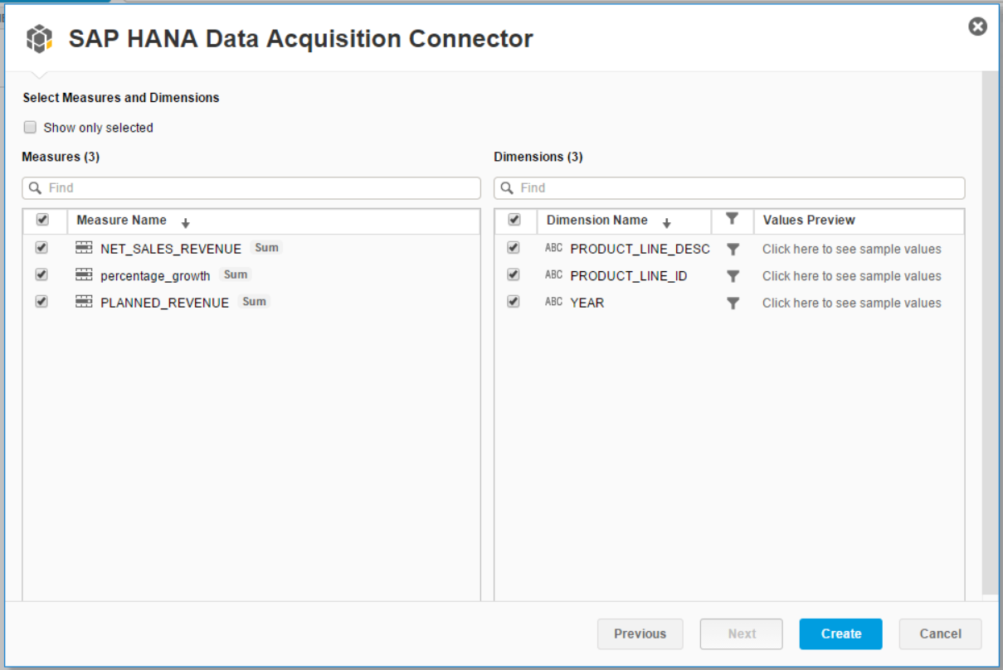

Click on Create.

In this section we are going to compare the planned revenue and the actual revenue over the years 2021 to 2026 using the line chart and also analyze the trend of the planned revenue.

6.1.) Place **year** under the **label axis (Dimension)** tab and place **planned_revenue** under the **value axis (Measure)** tab.

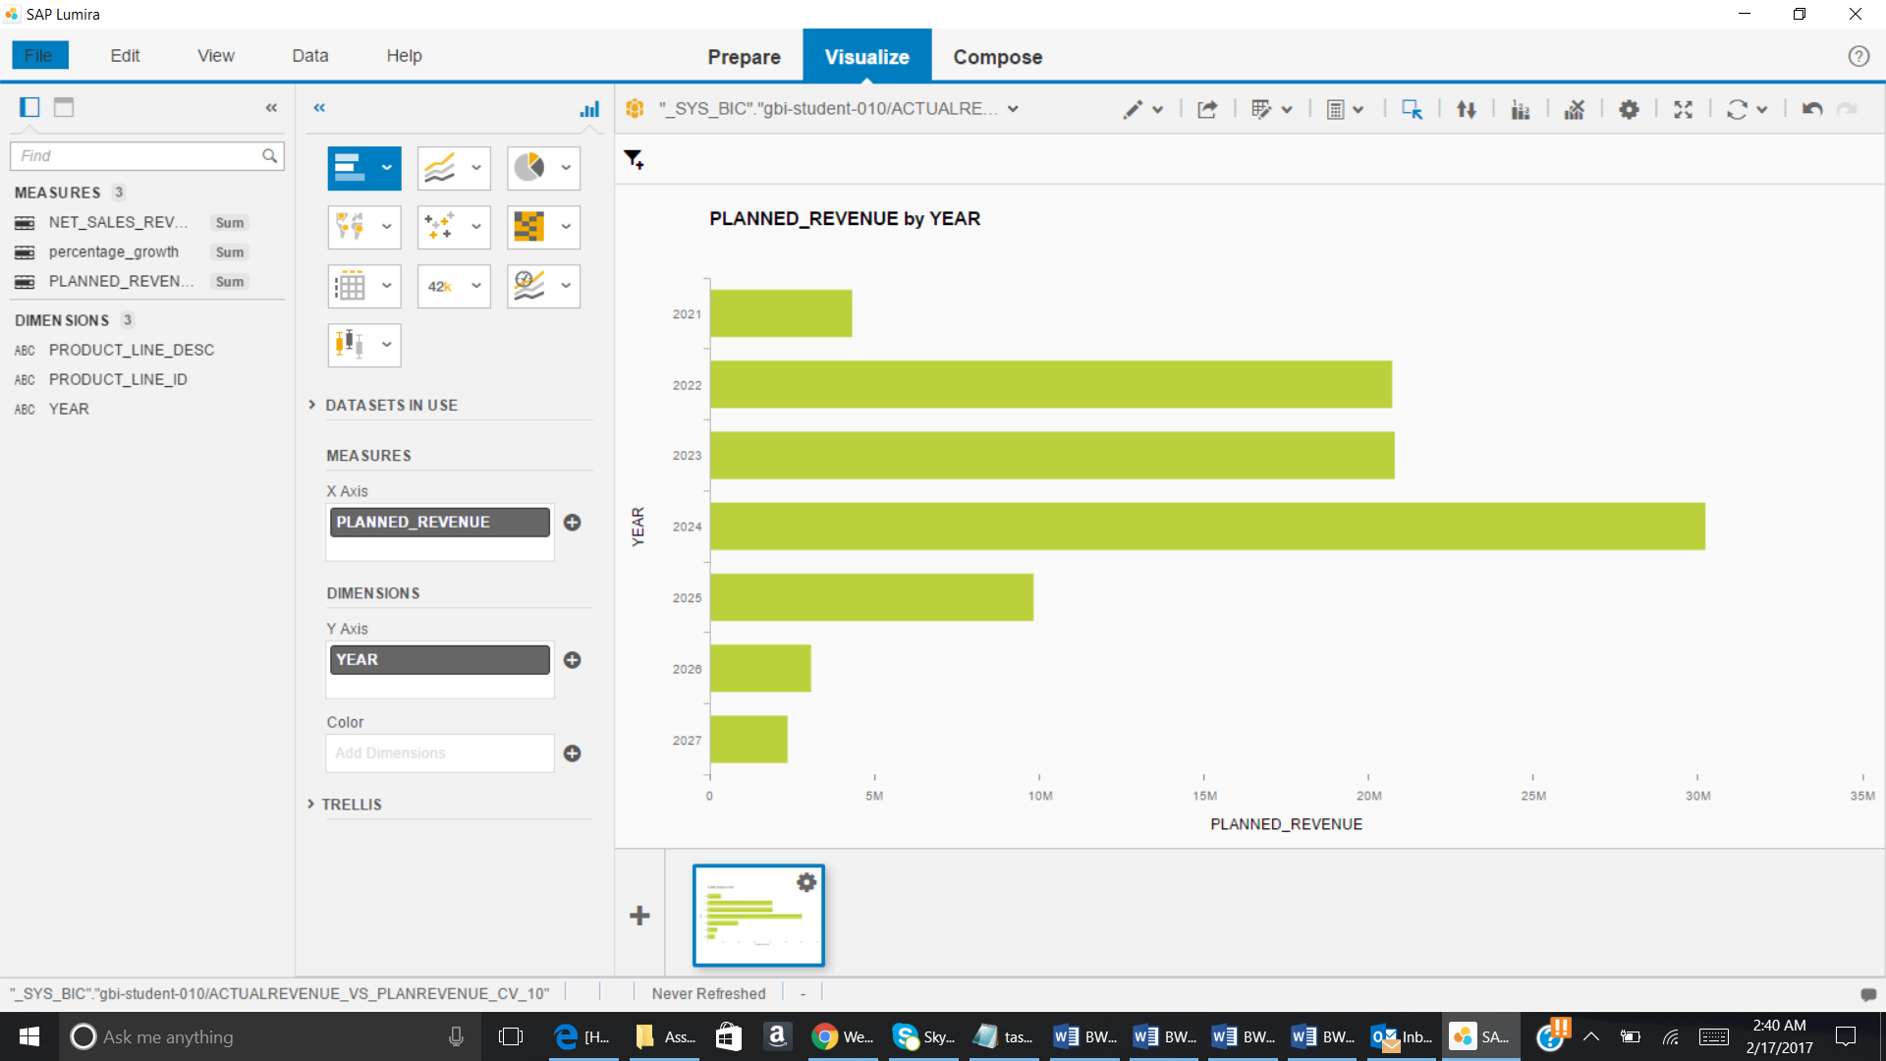

6.2) Under the type of charts, select the **line chart** and select the option **line**

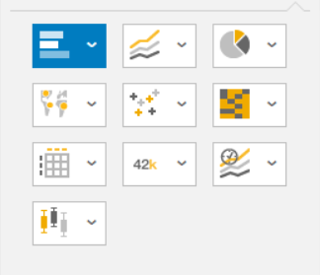

Click on highlighted part. You will get the below given dropdown.

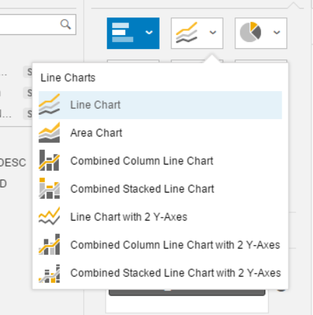

**Question: Paste the screen shot of the line chart**

**______________________________________________________________**

6.3.) Click on filter icon and then select year.

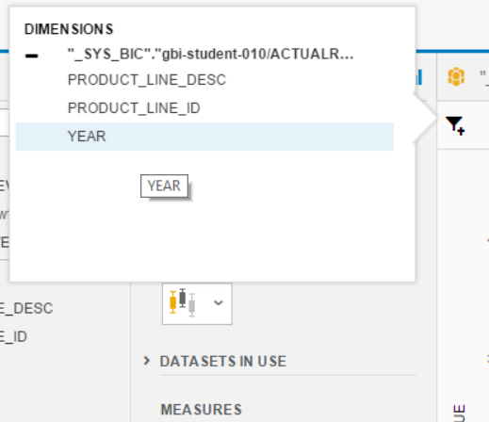

The below given pop up will come:

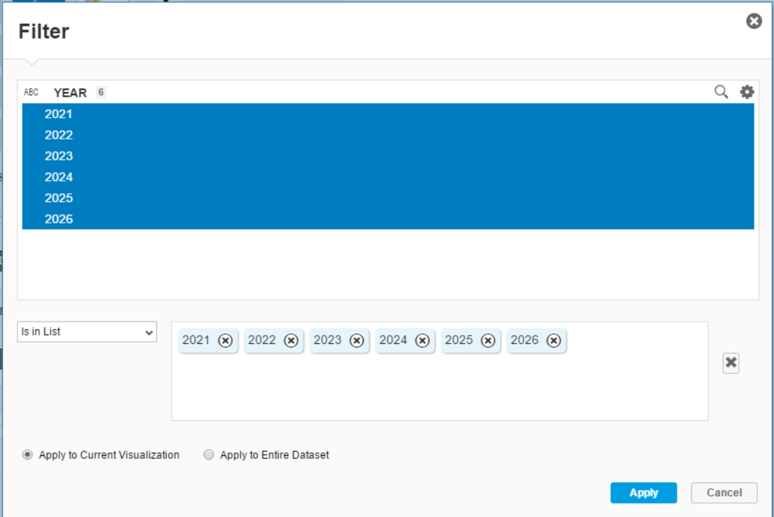

Now select year from 2021 to 2026 and then click on Apply.

6.4) Add the net_sales_revenue to the values axis (Measure) section as per the screenshot:

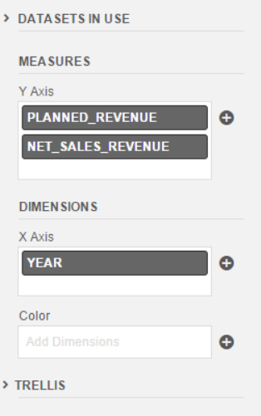

**Question: Paste the screen shot of your chart**

**_____________________________________________________________________**